Case Description | Screenshot | Test Result
Ensured resolution due time updated in the ticket field. | 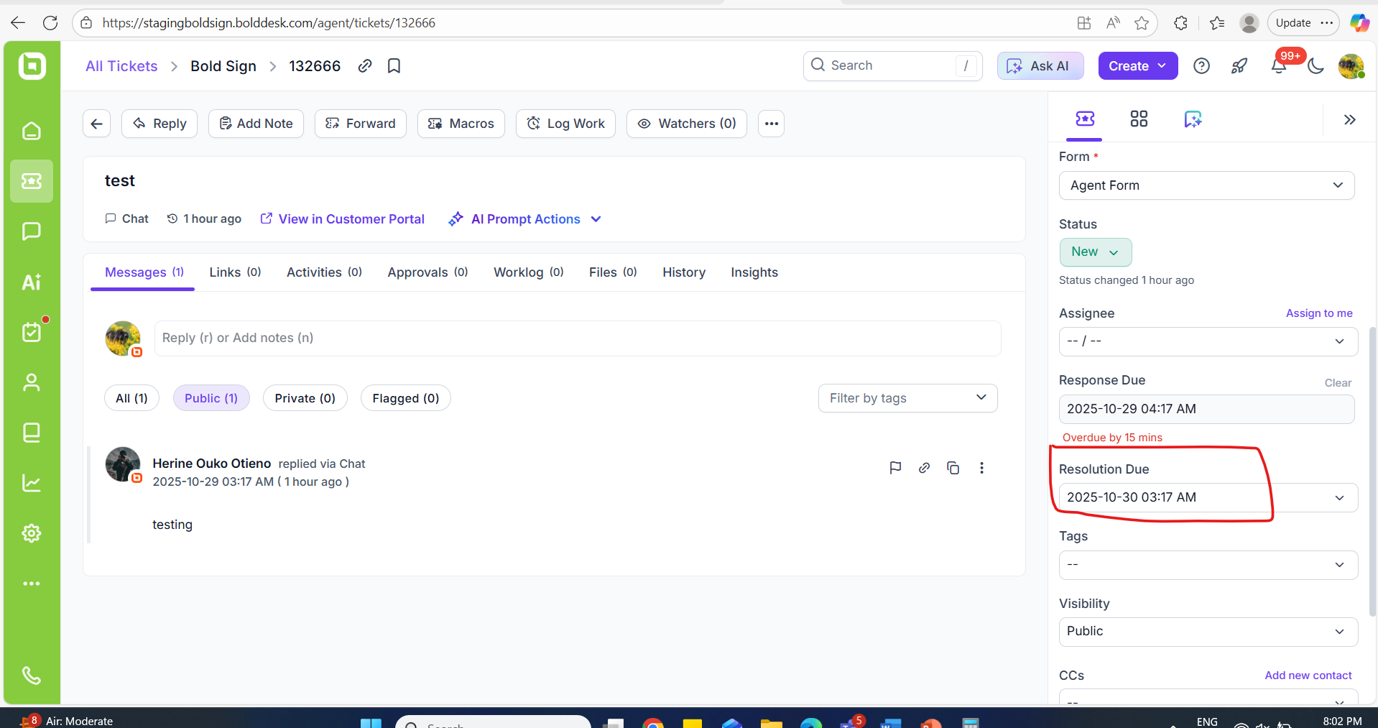 | Passed
Newly created ticket. | 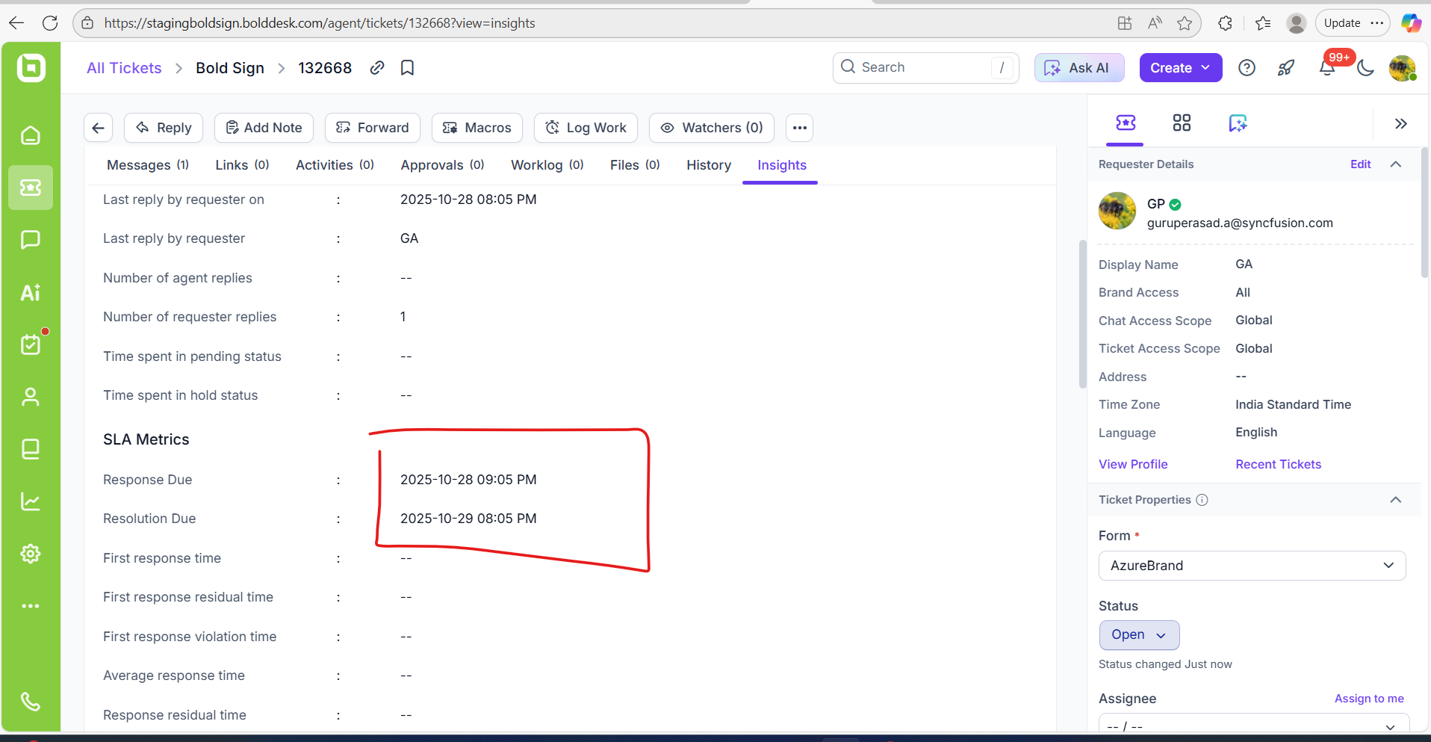  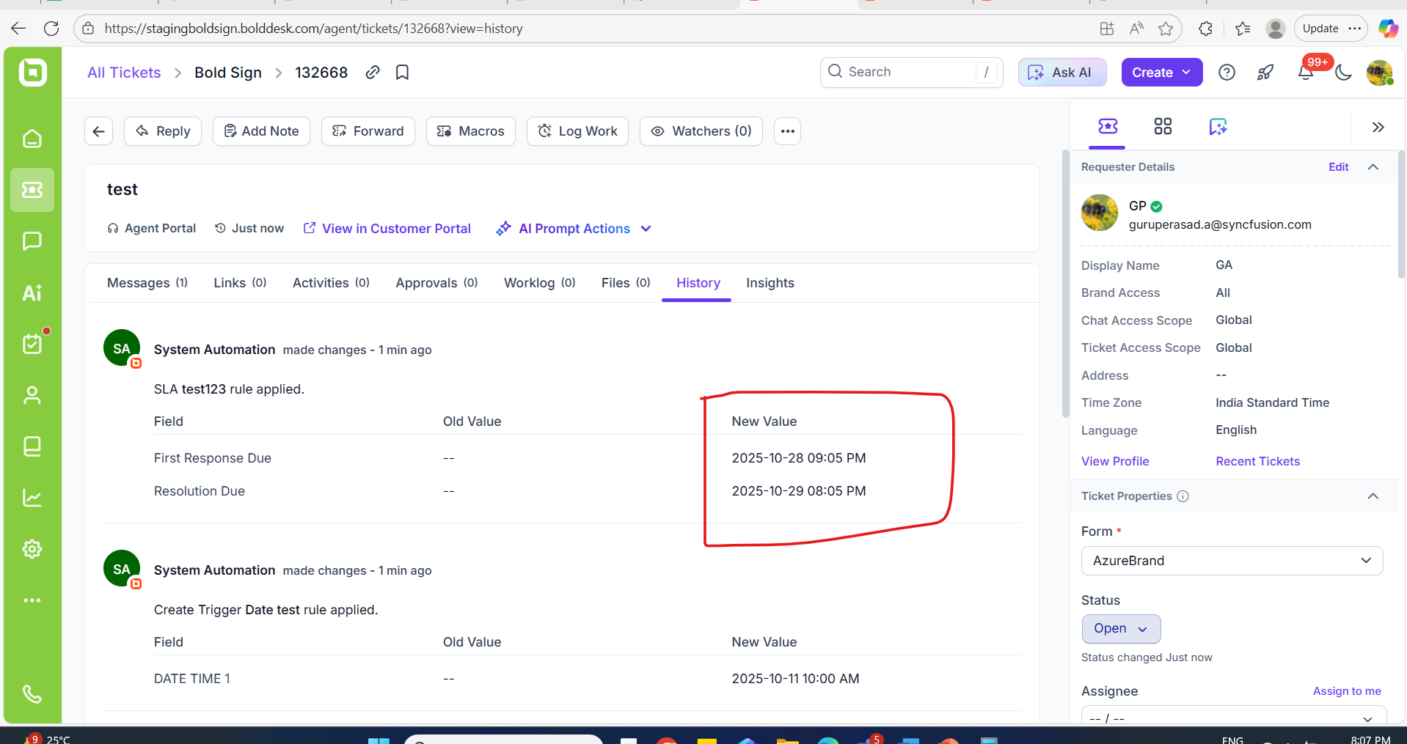 | Passed
While updating comments, requester reply count getting updated correctly. | 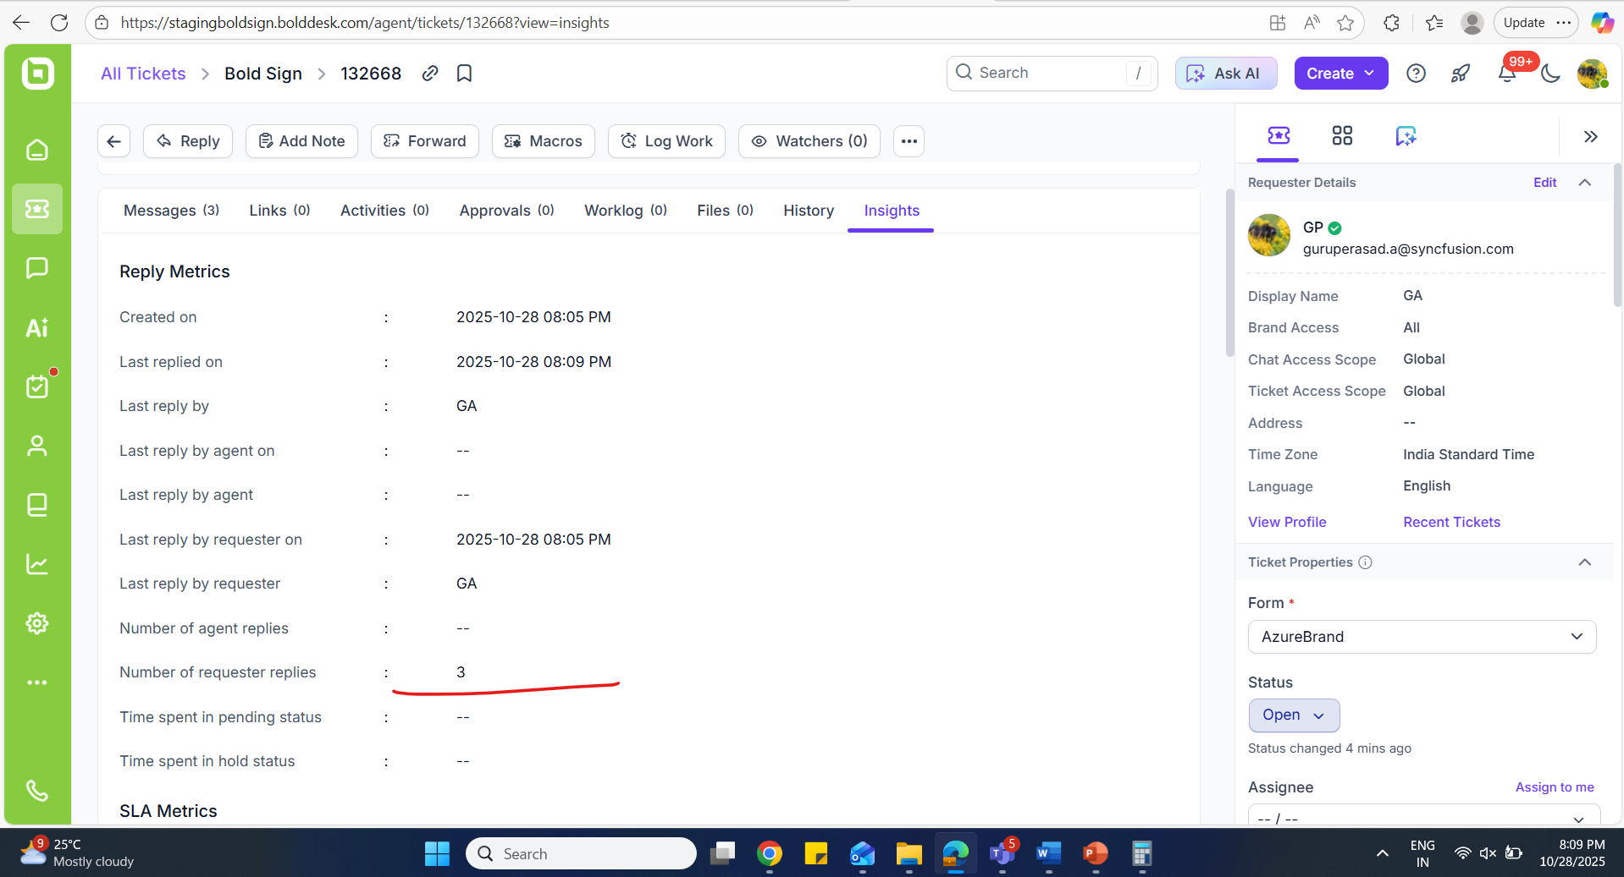  Created and close date:  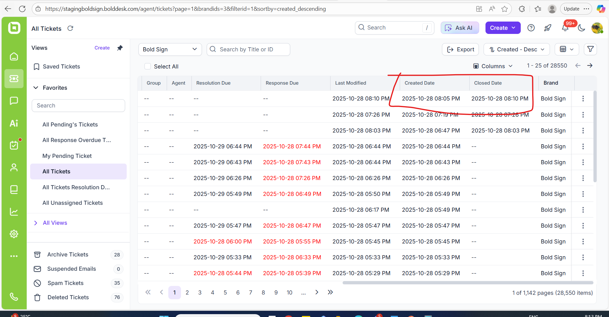  Time difference ensured in Insights tab:  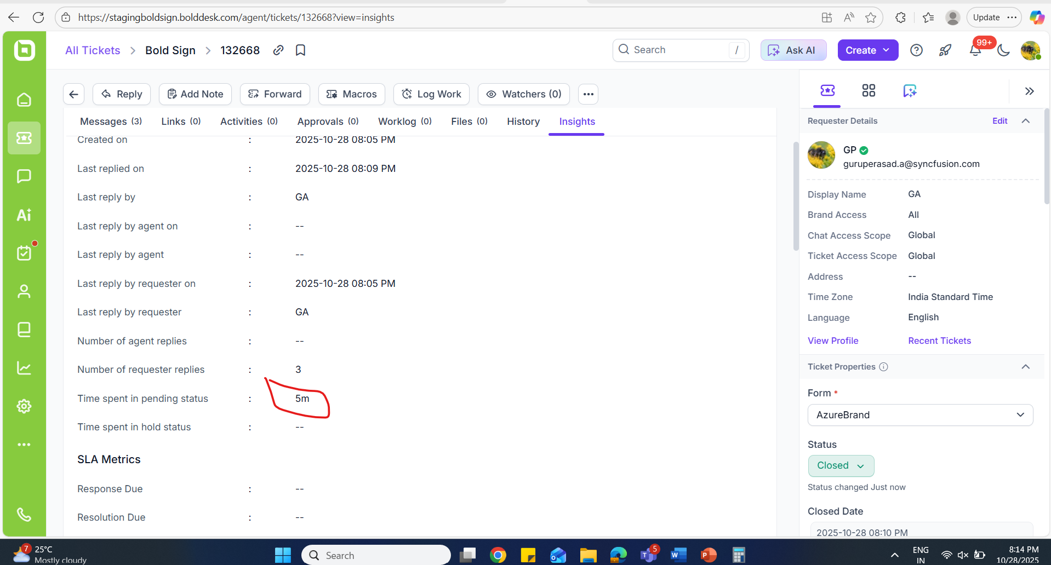  Status changed to – Solved:  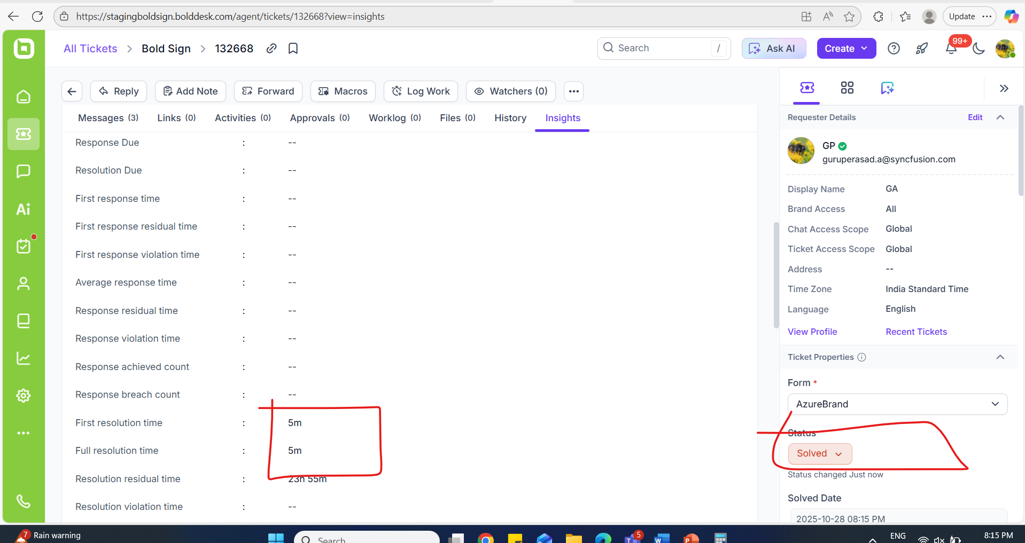  Ticket closed time:  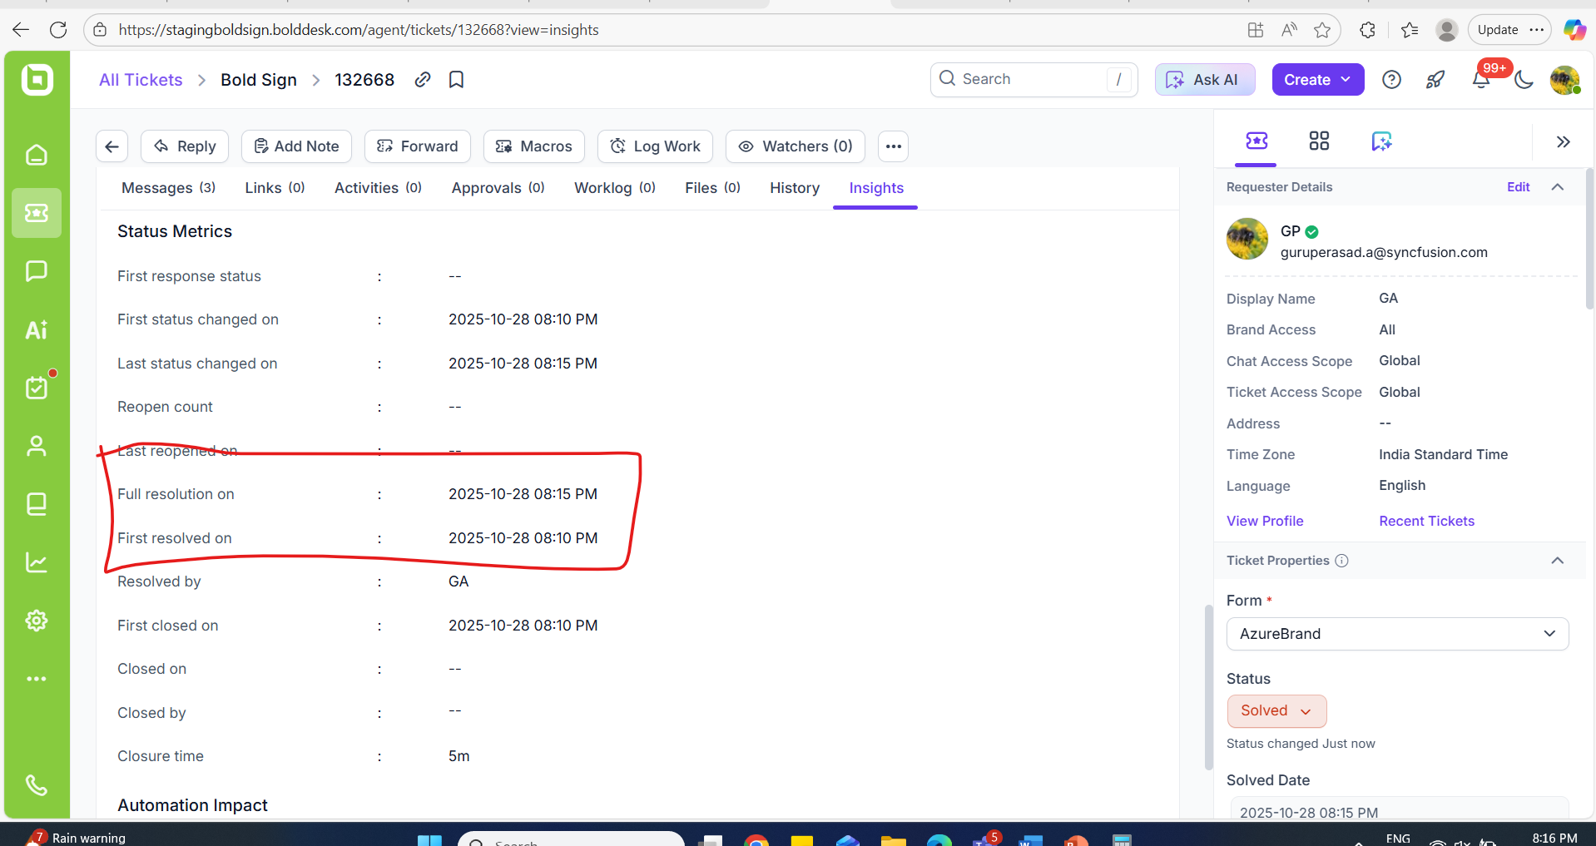 | Passed
 | 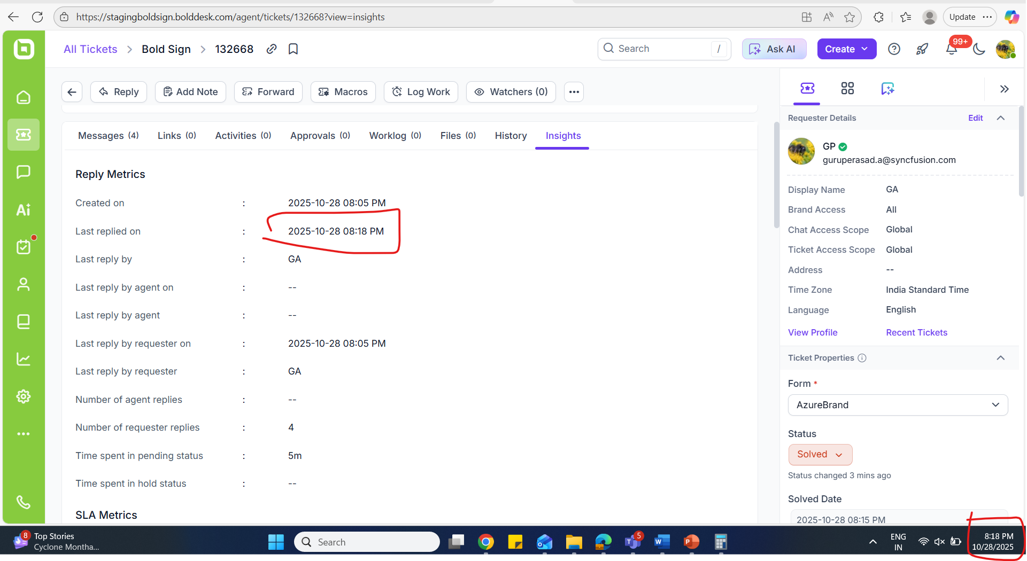 | Passed
Ensured Time related property details in ticket grid view with Insights tab. | 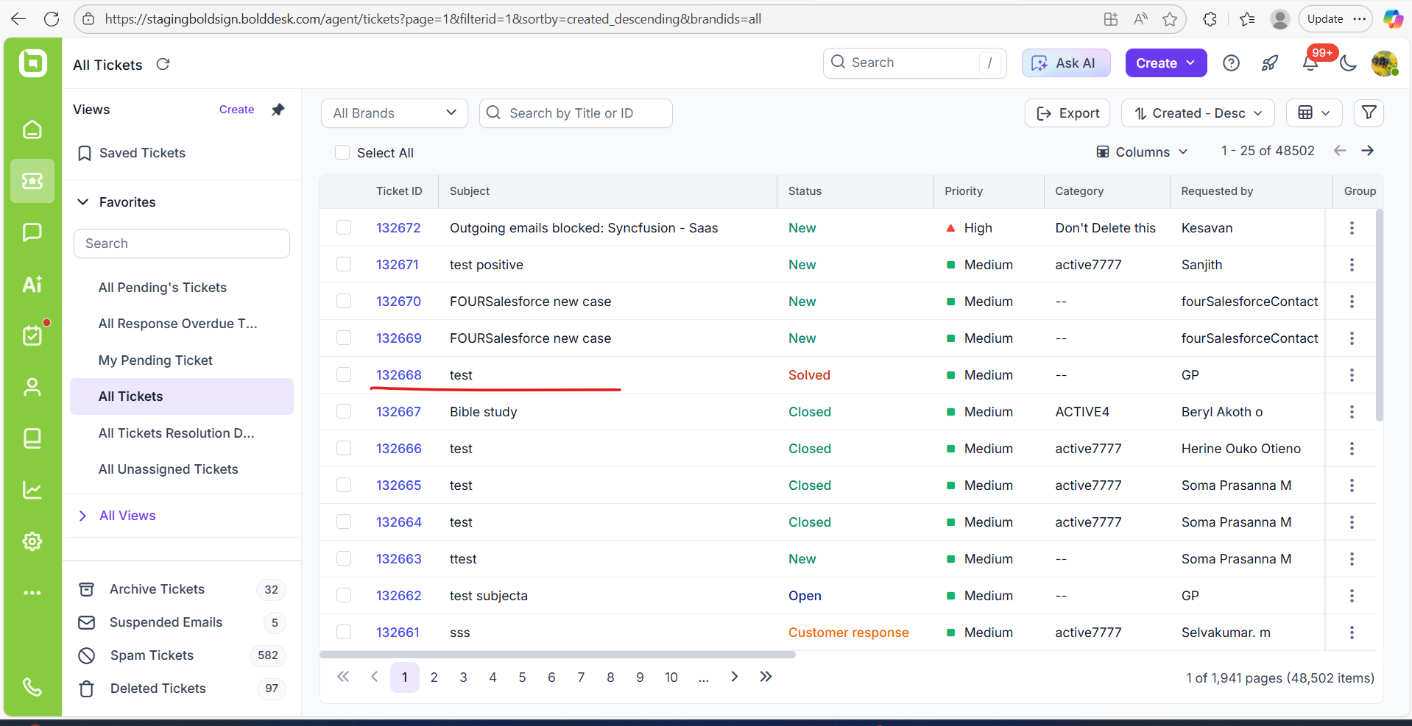  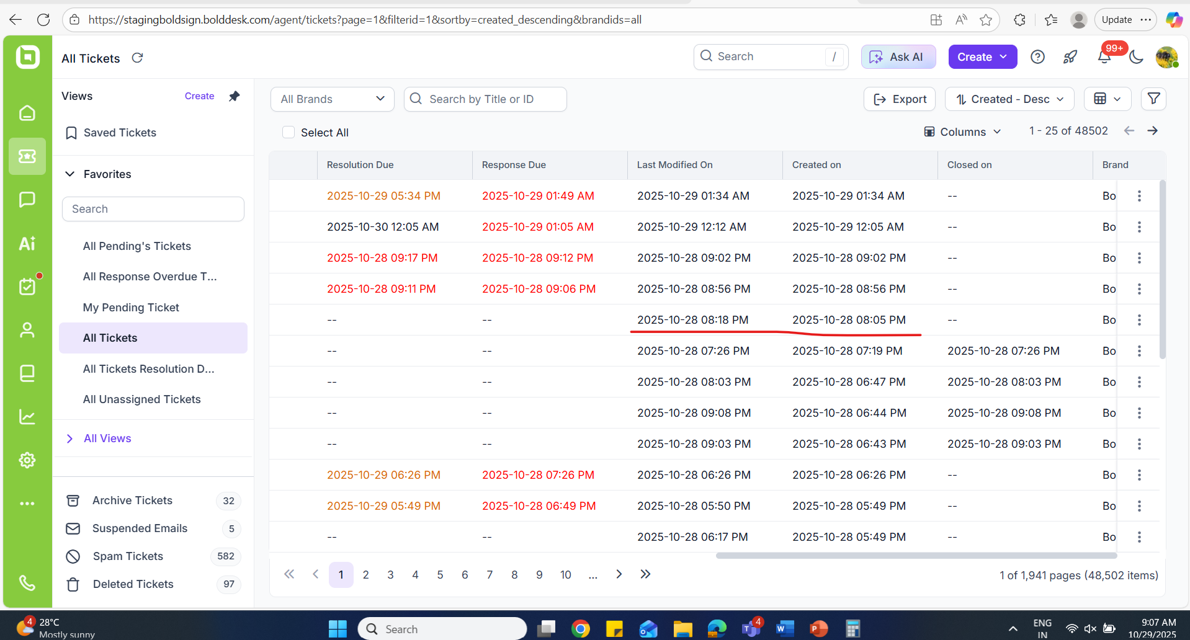 | Passed
Verify the closed date, time and timezone in the field when changing the status to closed. | 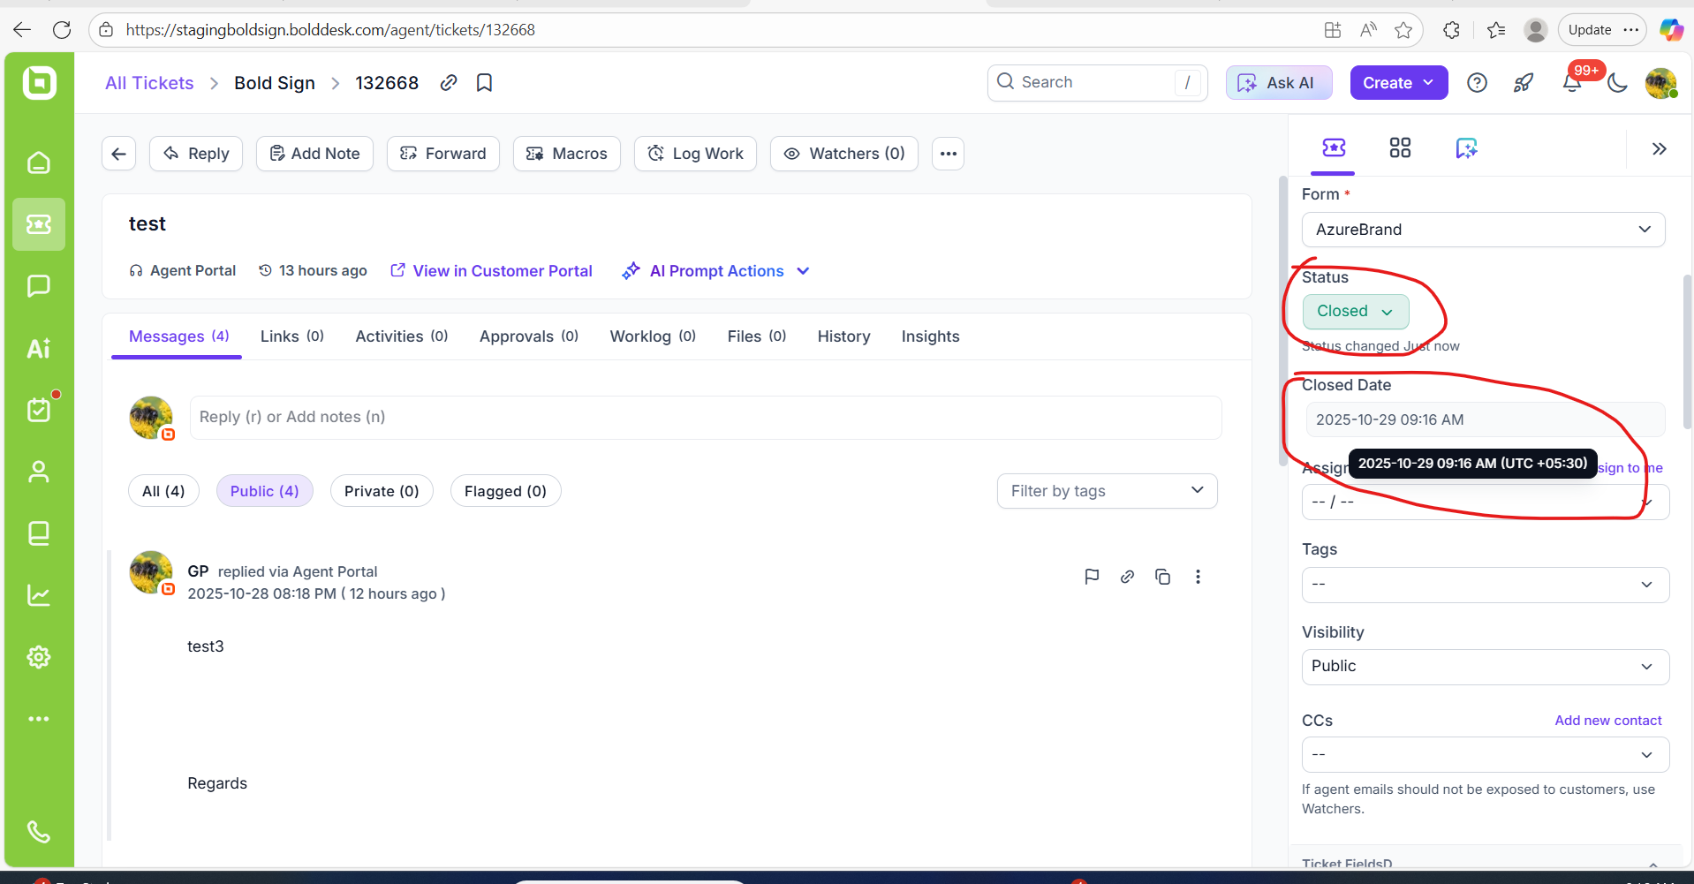 | Passed
Verify the closed date and time and timezone in the field when changing the status to Solved. | 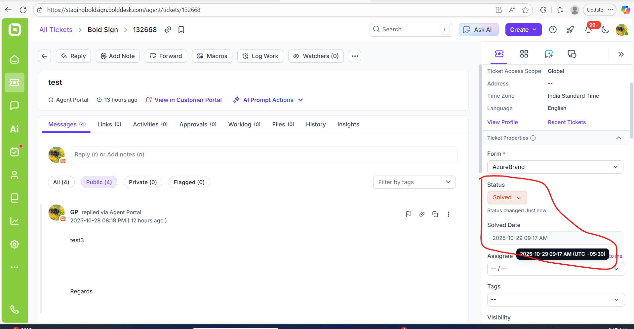 | PASSED
Verify the on-hold date , time and timezone in the field when changing the status to On-hold. | 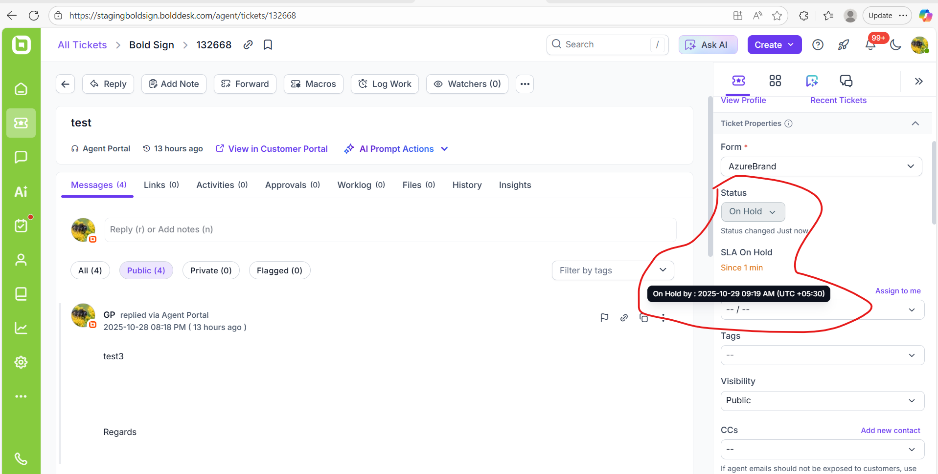 | Passed.
Verify by updating On-hold status ticket to closed status.  Ensured date, time and timezone in the ticket detail. | 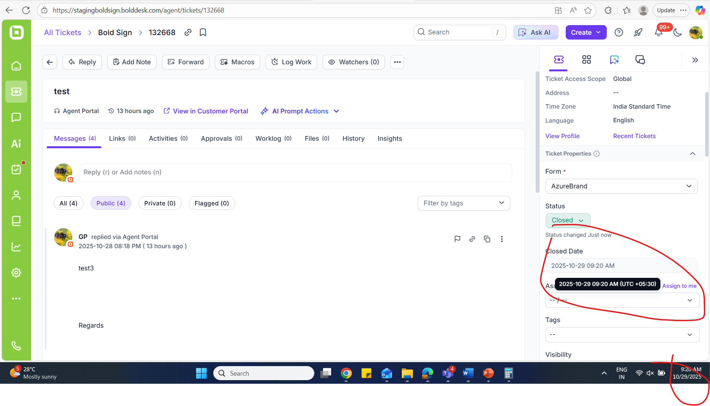 | Passed
 | 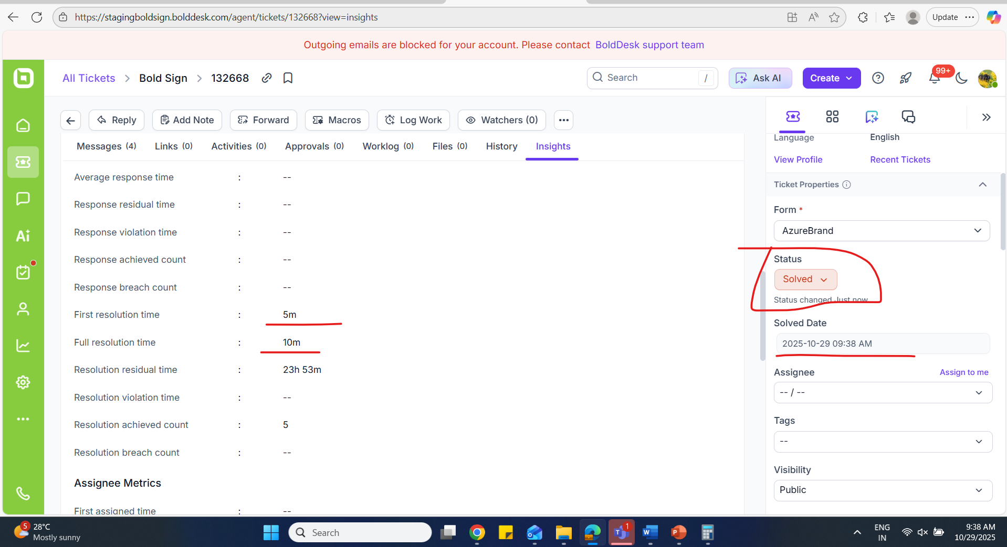  When changing ticket status Solved to closed “Full resolution time” not to be taken into consideration:  Previous value to be displayed.  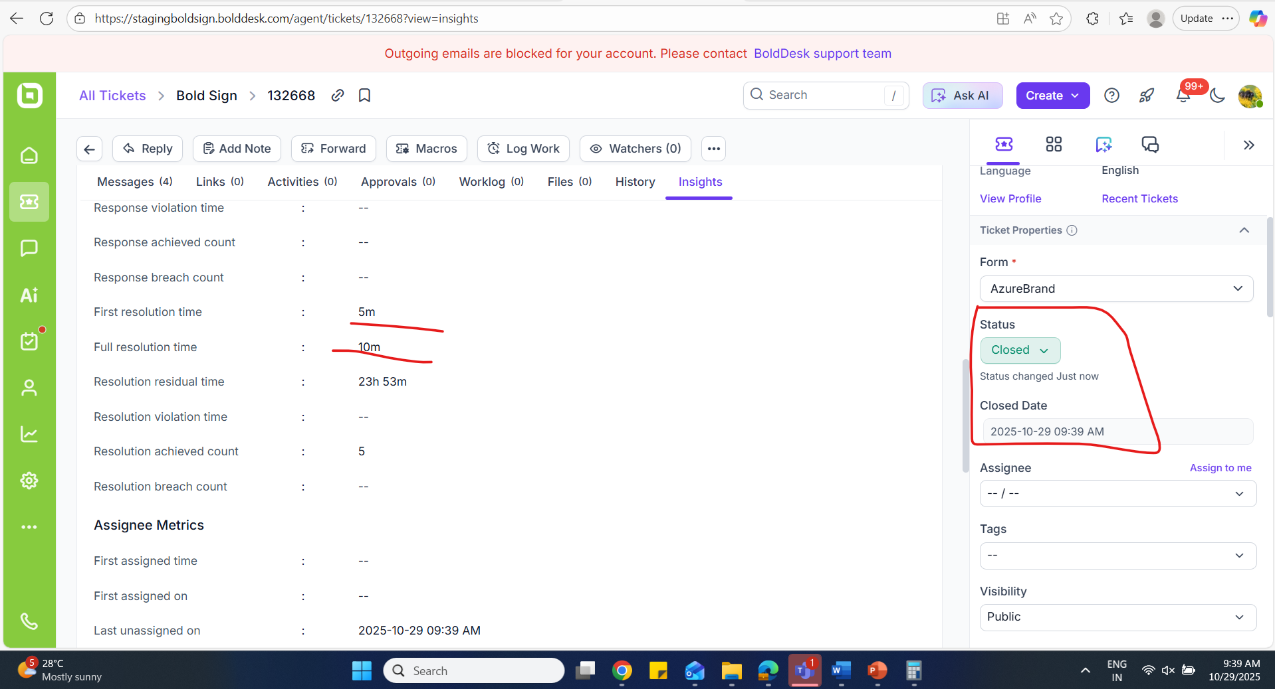 | Passed
Ensure ‘Last status changed on’ and ‘Full resolution on’ time in the Insights tab. | 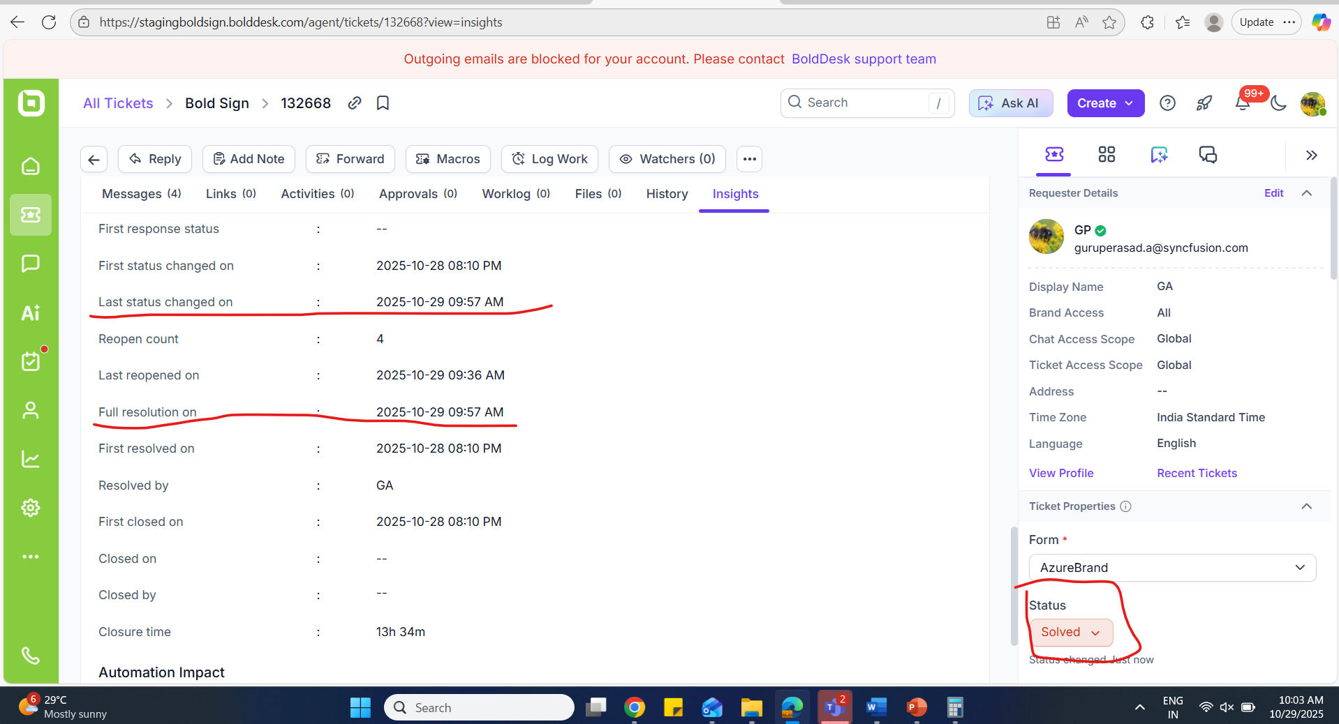 | Passed
Ensured re-open count properly updated .  1)While changing ticket status from closed to open – Re-open count to be updated correctly.  2)While changing the status from open to other status count not to be updated in the field. | 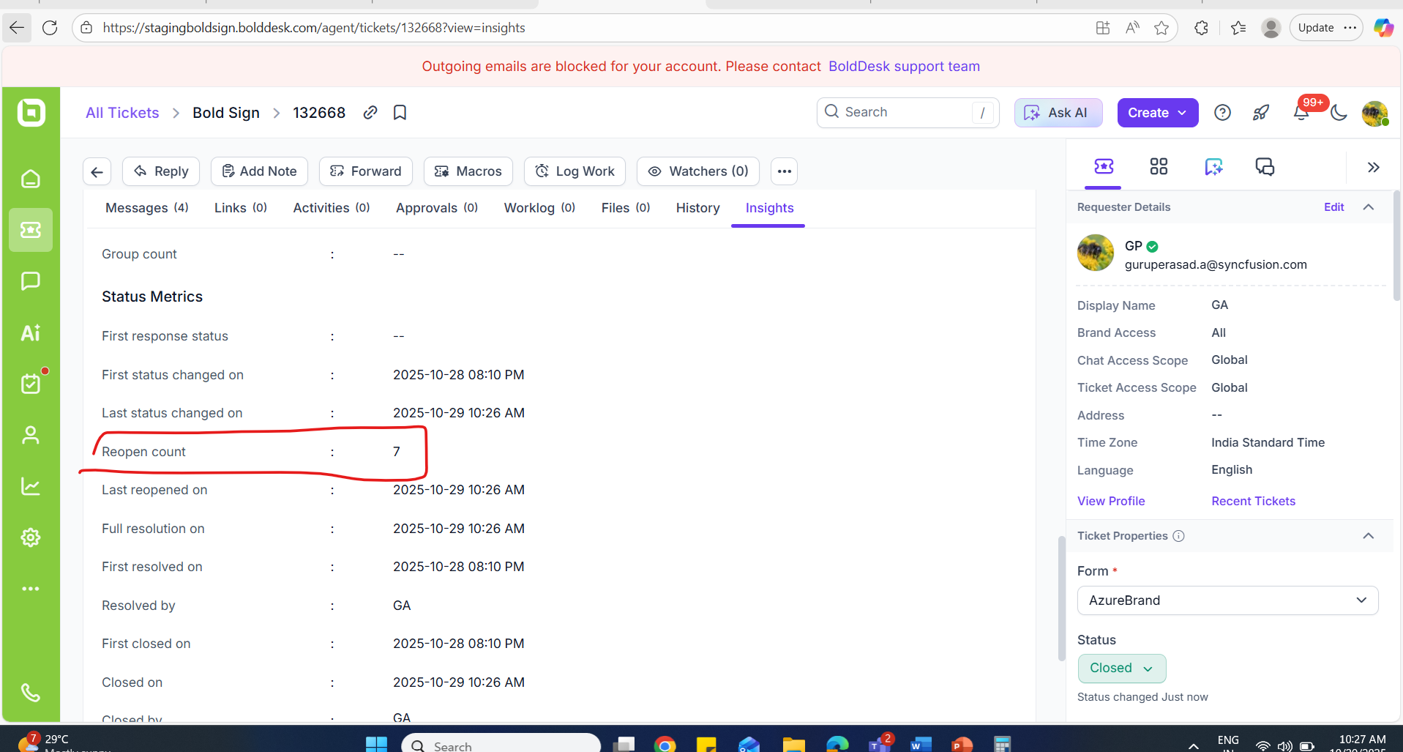 | Passed
Ensured while changing status from solved to onhold, waiting for customer, escalated, open, Customer response count updated properly in “Re-open count”. | PASSED
Ensured while changing status from CLOSED to onhold, waiting for customer, escalated, open, Customer response count updated properly in “Re-open count”. | PASSED
Ensure Full resolution time and resolution residual time in the Insights tab. | 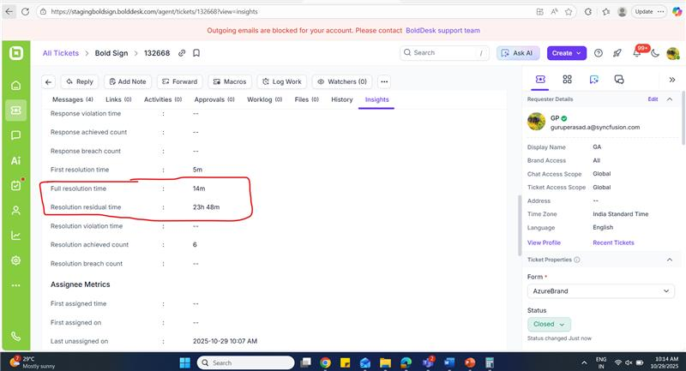 | FAILED  (Resolution residual time mismatches)
Ensure the resolution residual time calculation.  Resolution Time Calculation:  Resolution time is calculated from the ticket is opened until it is closed. If the ticket is closed multiple times (e.g., moved from Closed to Resolved repeatedly), the full resolution time gets added each time. | ticket, latest resolution time is  2025-10-30 10:25 AM  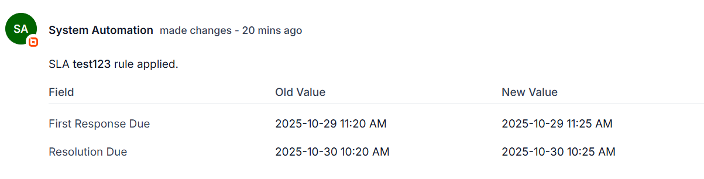  last closed on is  2025-10-29 10:47 AM    Residual time is : resolution due time - last closed on time [2025-10-30 10:25 AM - 2025-10-29 10:47 AM] ==> 23h 38m   | PASSED  ( aS PER THE CALCULATION TIME IS CORRECT)
Ensured closed date and time updated properly when changing the status from  - solved to closed.  - Closed to solved. | Closed date and time:  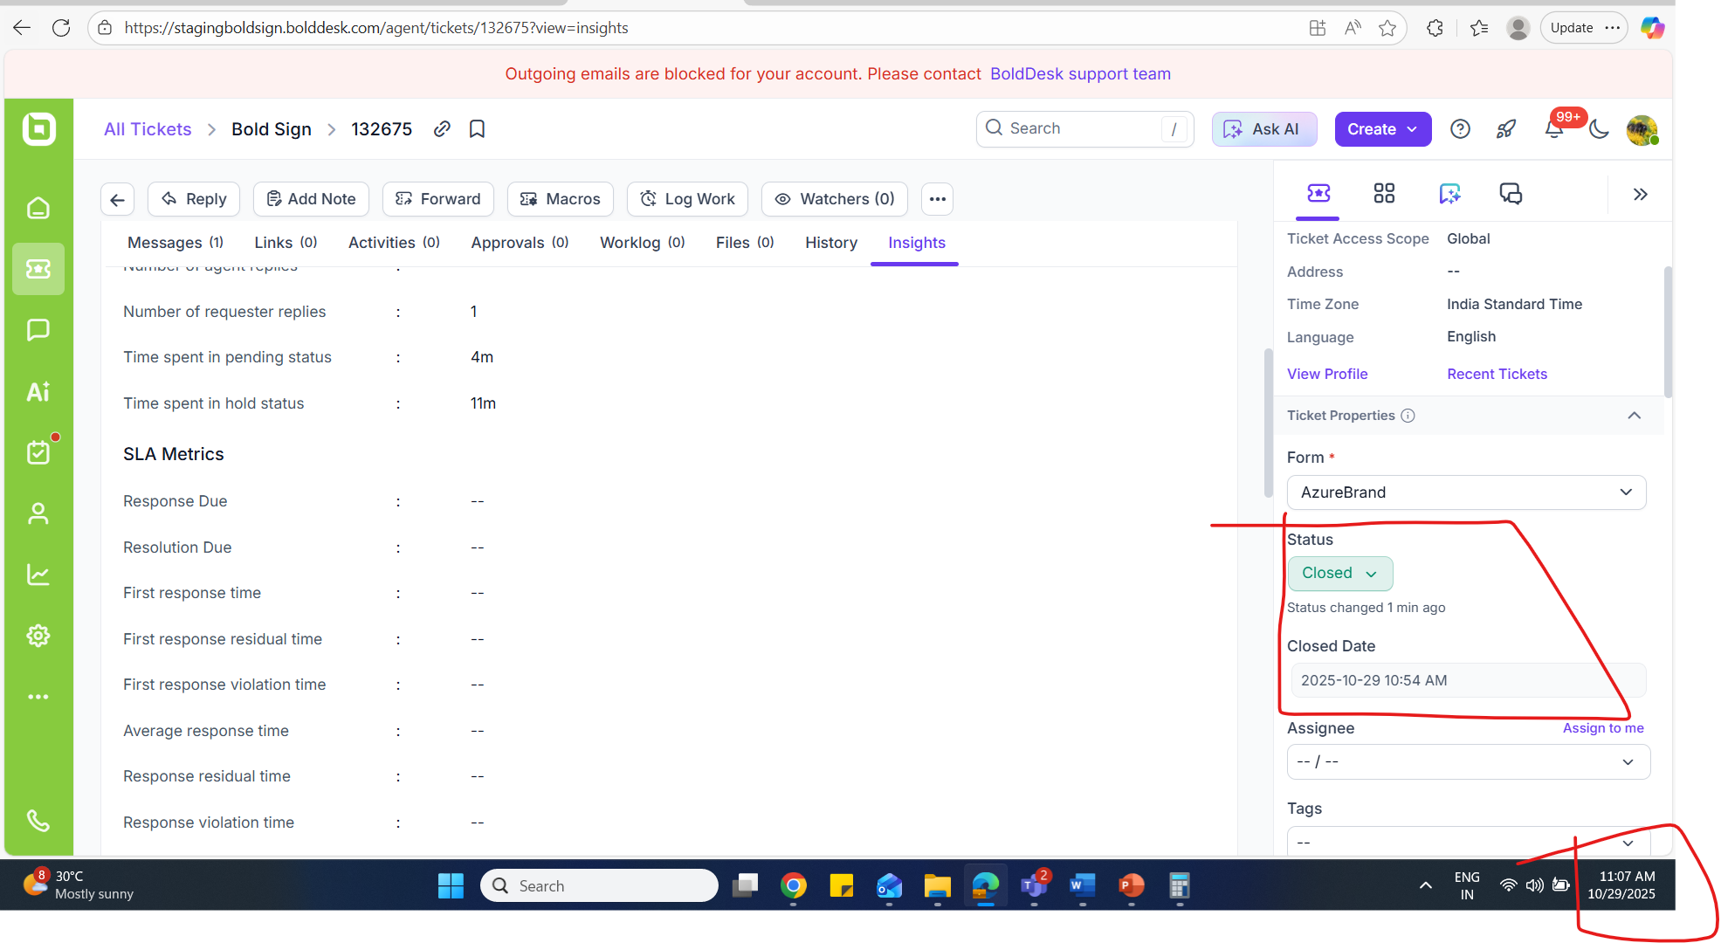  Updating status to “Solved” status:  Time to be updated correctly as expected:  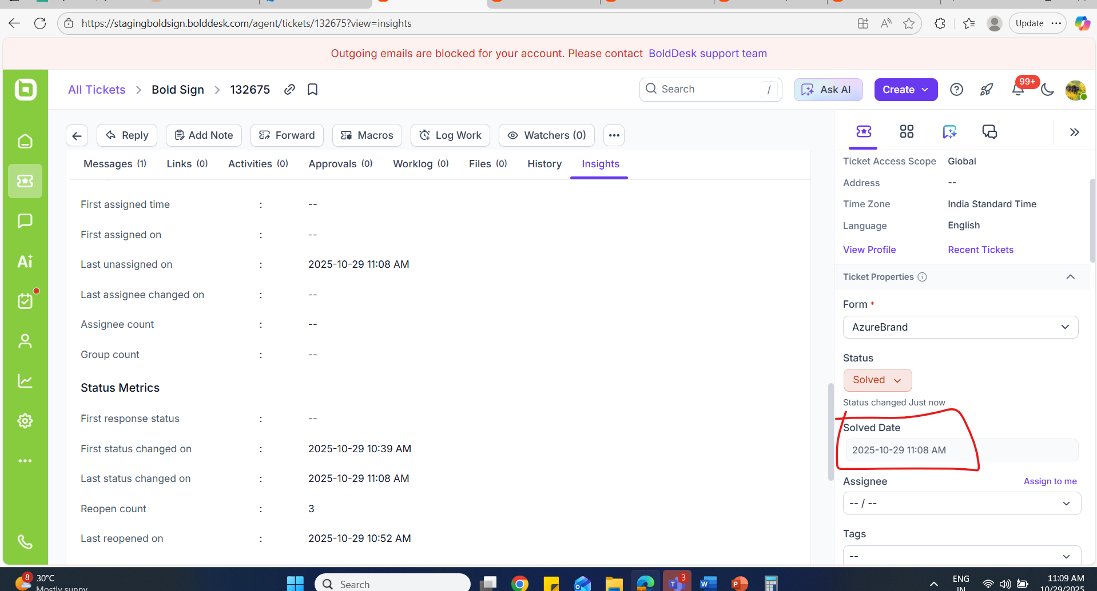 | PASSED
Ensure full resolution on time in Insights tab while changing status to closed and solved. | We can note initially status in "Solved"  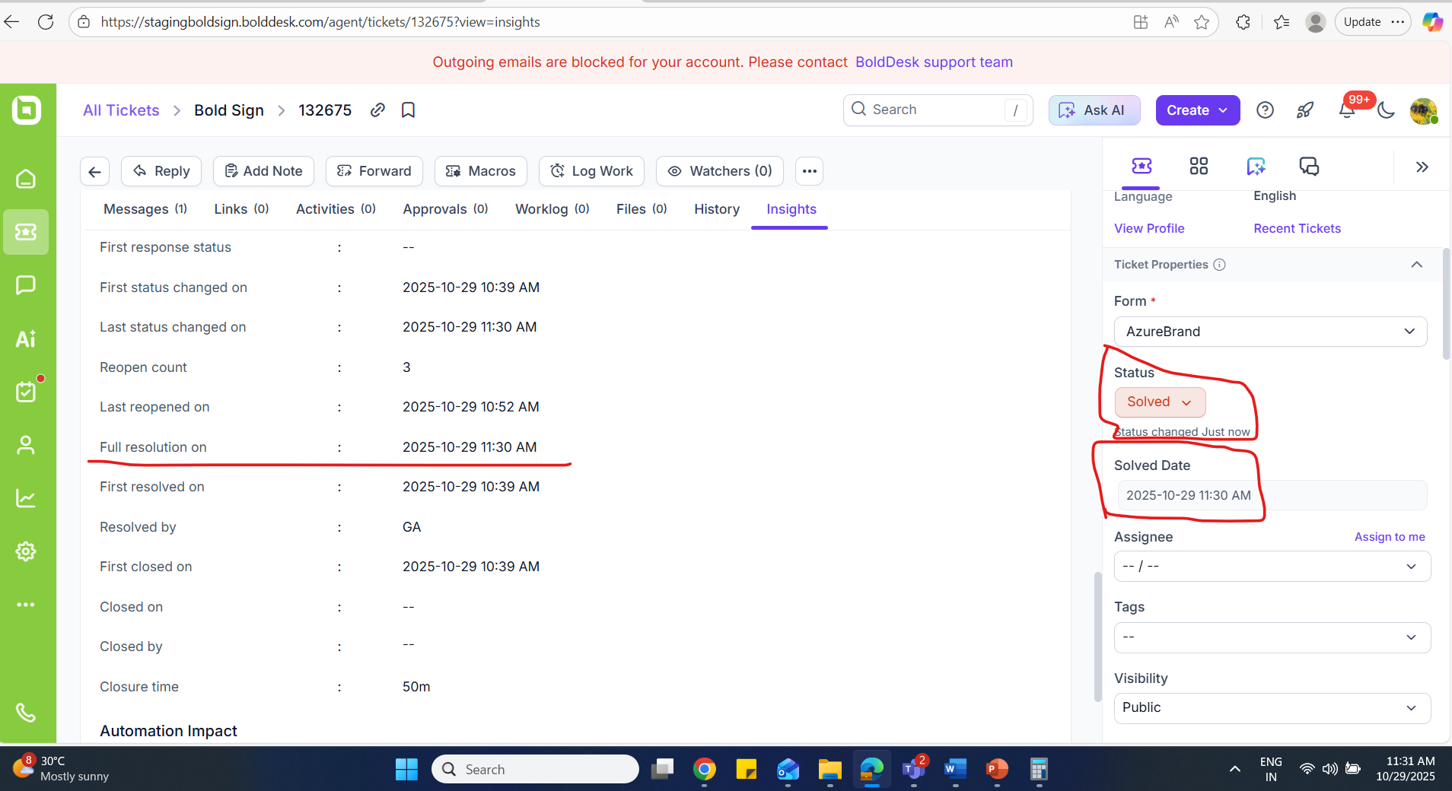  While changing status to "Closed" time not updated in the "Full resolution on" field:  We can note time difference in ticket property -"Closed status" and in "Status metrics" - Full resolution on field.  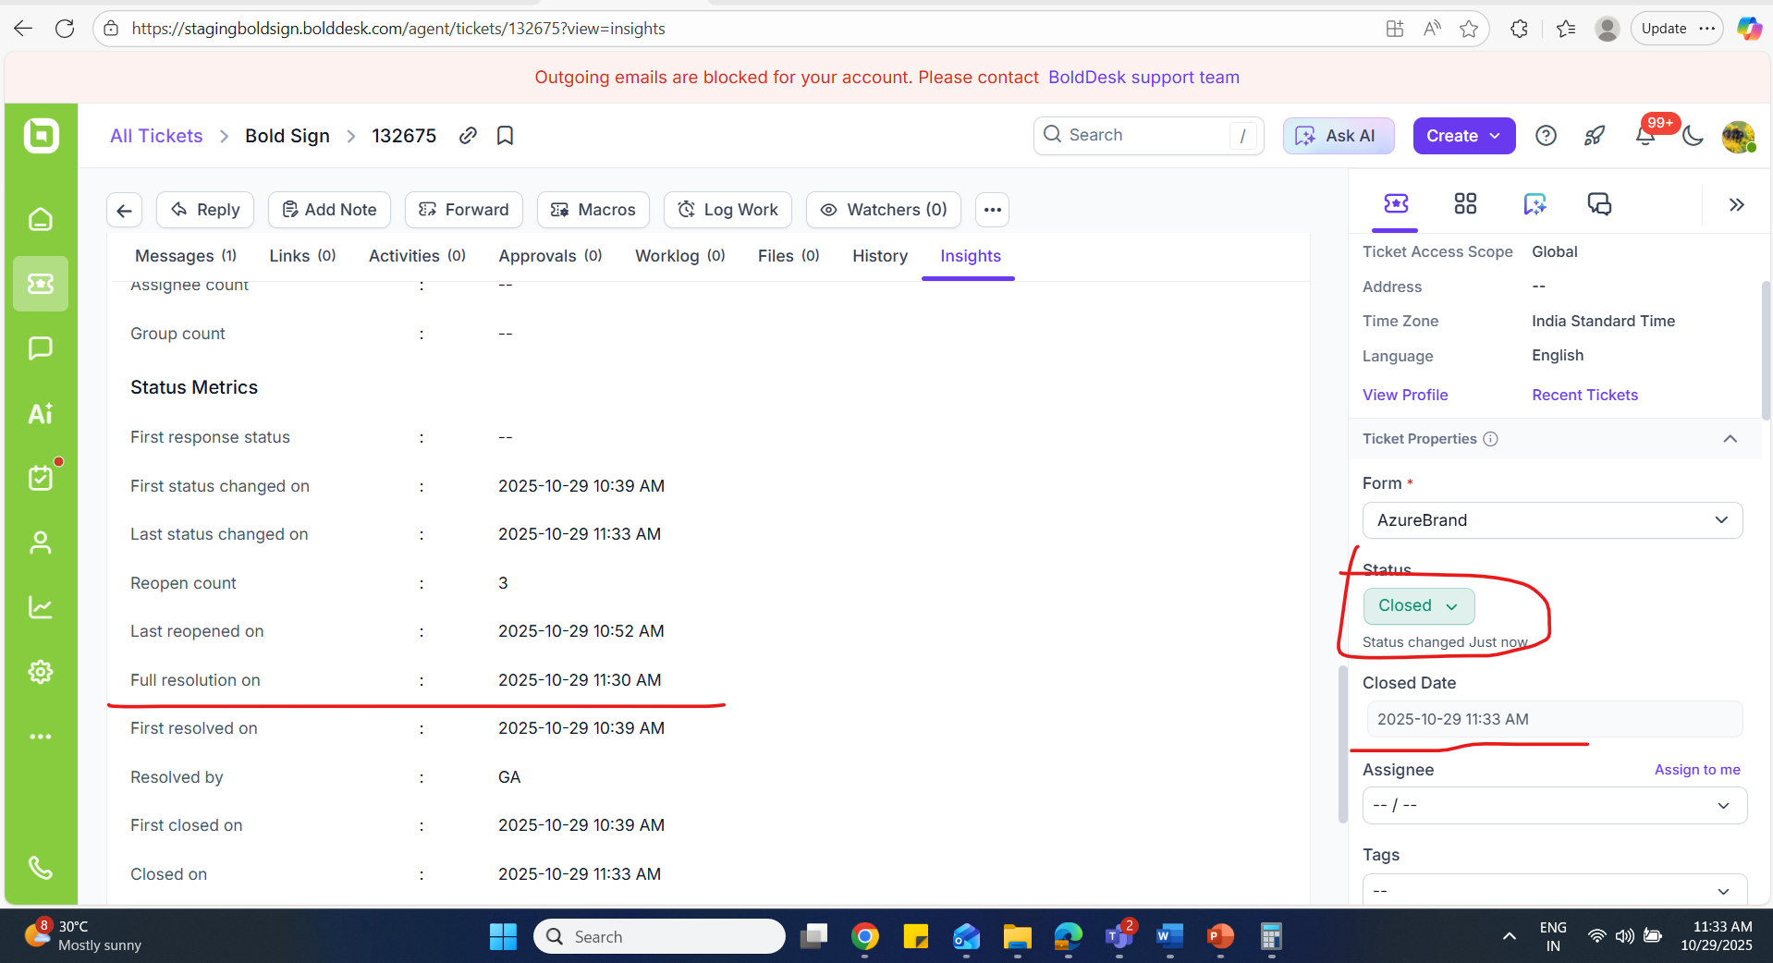  We can note while changing status to solved "Full resolution on" time field get updated:  Solved date below status field in ticket property and Full resolution on date in Insights tab time both seems to be same.  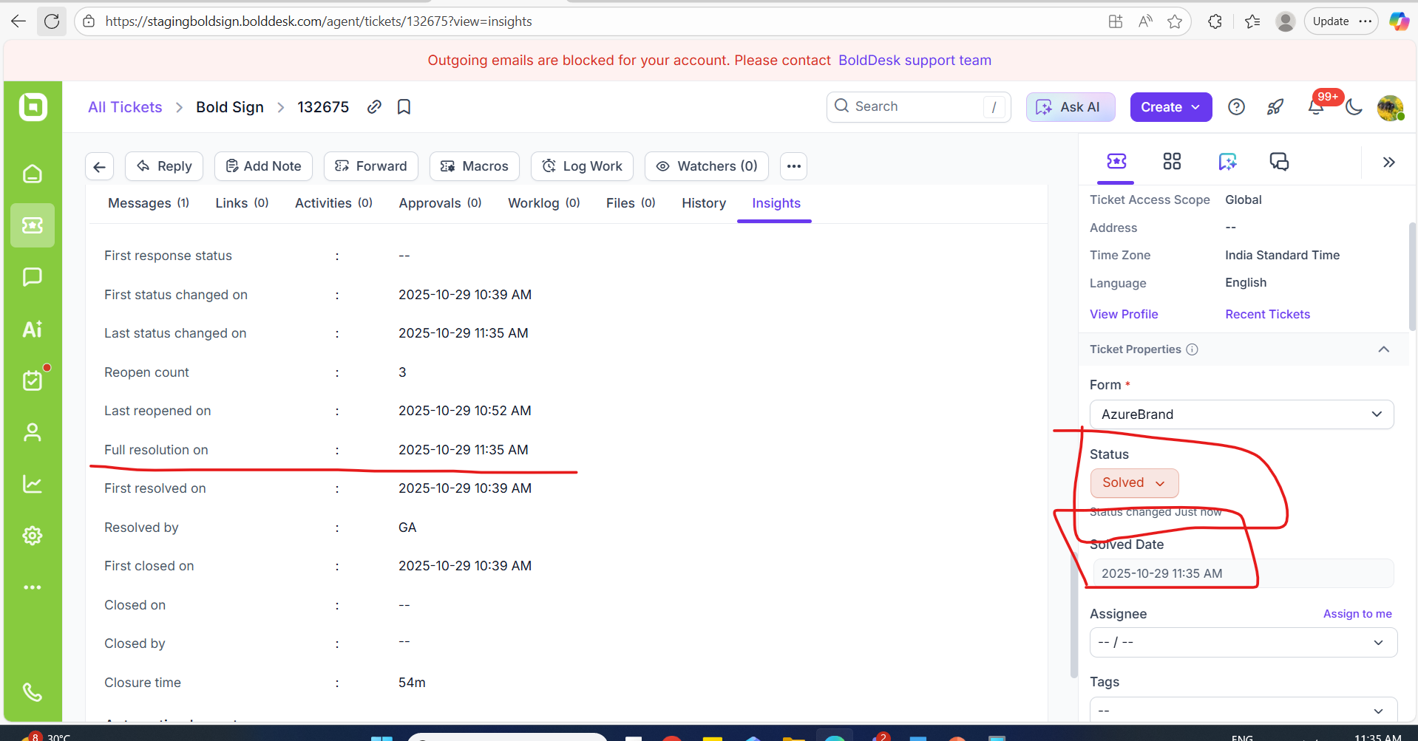 | FAILED  (In-consistency in time update in insights tab)
Ensure the closure time while changing the status.  Solved to closed.  Closed to solved. | Solved status:  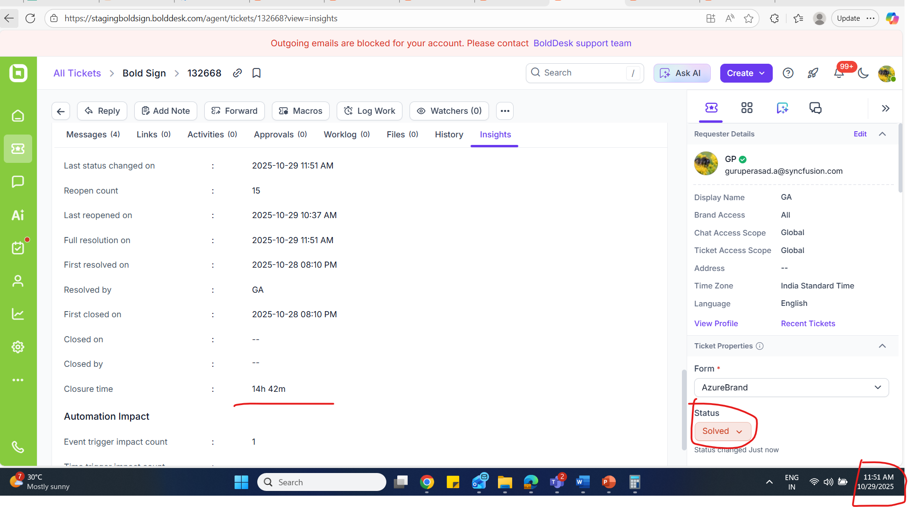  While changing status from solved to closed:  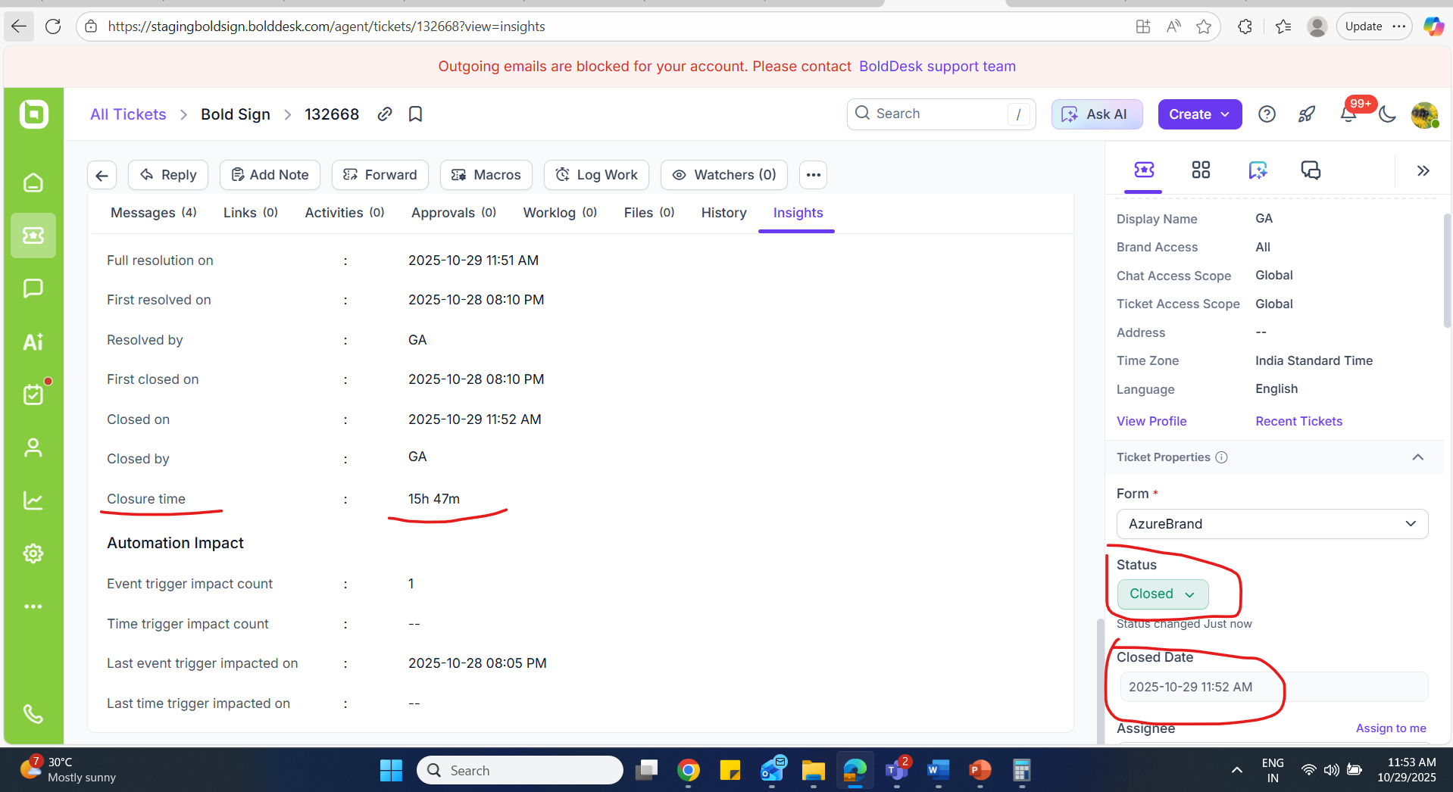  While changing status from closed to solved:  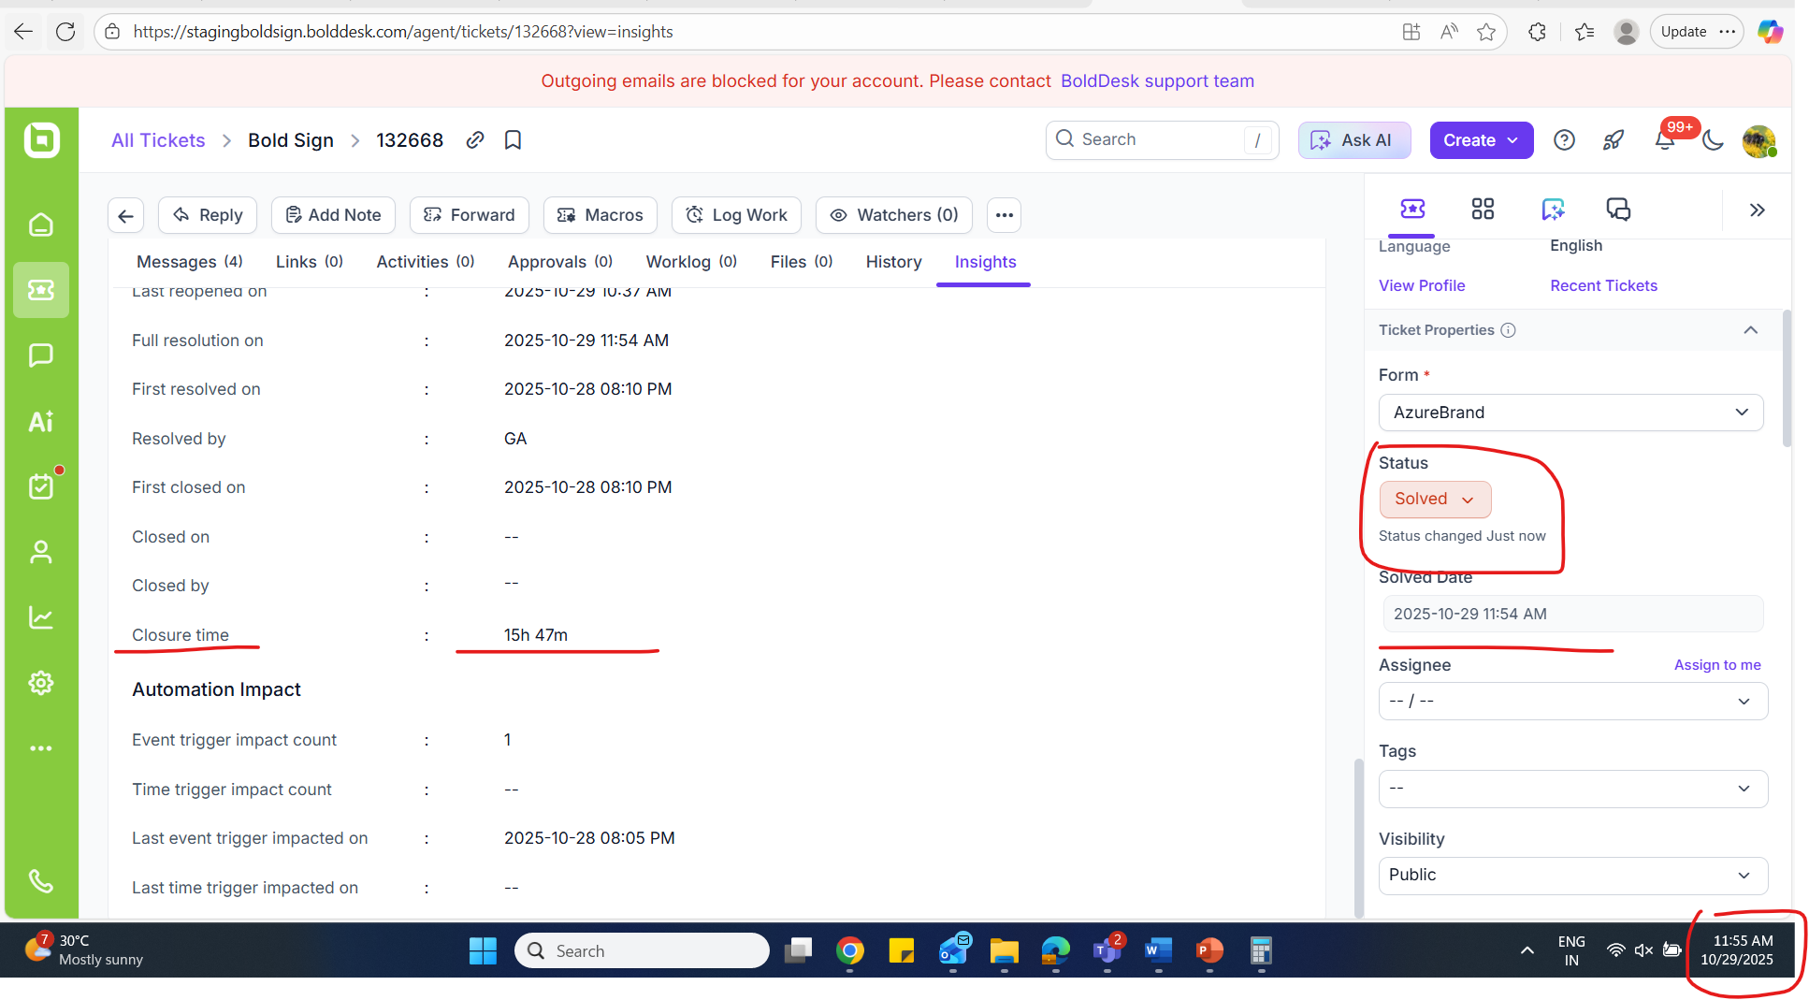 | FAILED
Verify by marking field status as “Closed” or “solved” and ensure the values in the field – Insights tab. | While marking ticket as "solved" - status, we are not updating the below Metrics field values in Insights tab.  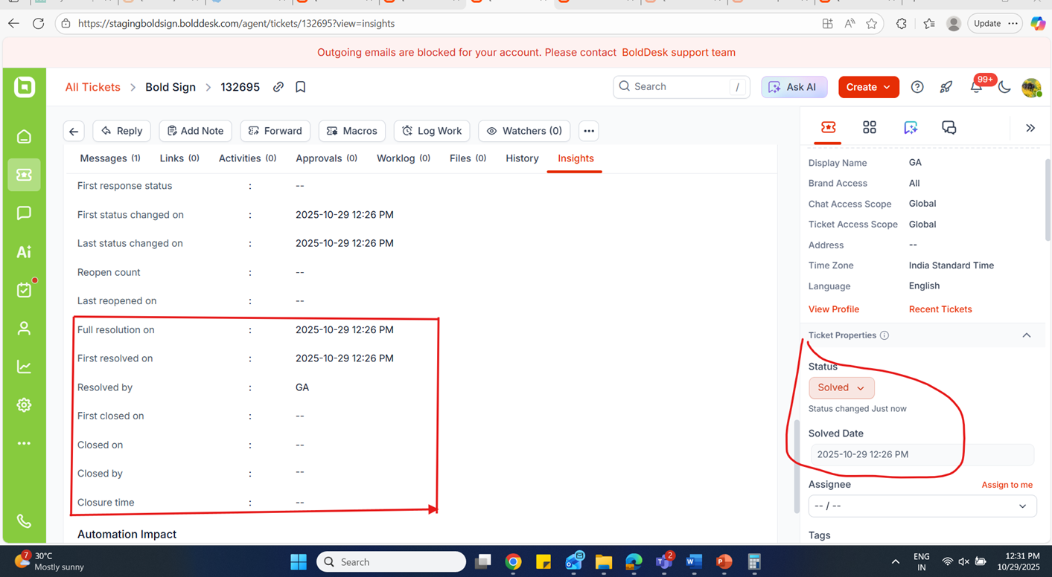  But while marking status as closed, we are updating the field values.  Since, closed and solved status are same category can we update the values while changing the status field.  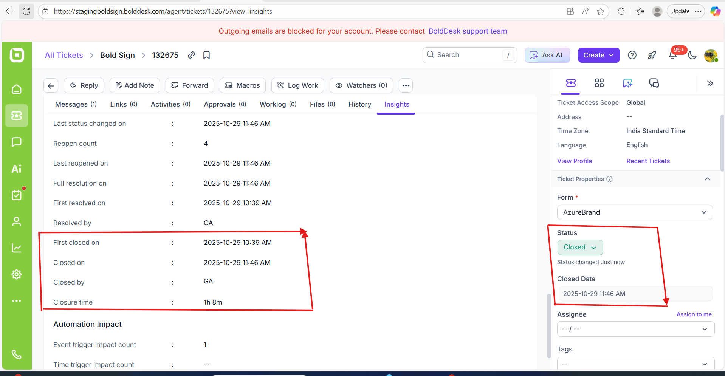 | FAILED  (fIELD VALUE NOT UPDATED WHILE MARKING STATUS AS cLOSED AND SOLVED)
While changing ticket status to  Solved, and ensured “Full resolution time” updated correctly. | 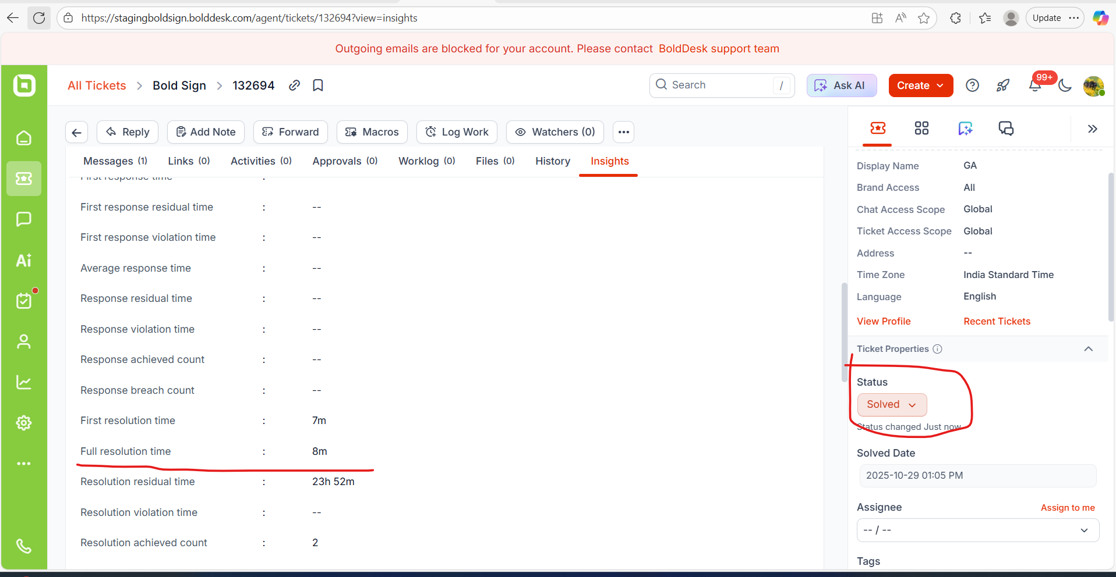 | PASSED
While changing ticket status to  Closed, and ensured “Full resolution time” updated correctly. | While changing ticket status to closed:  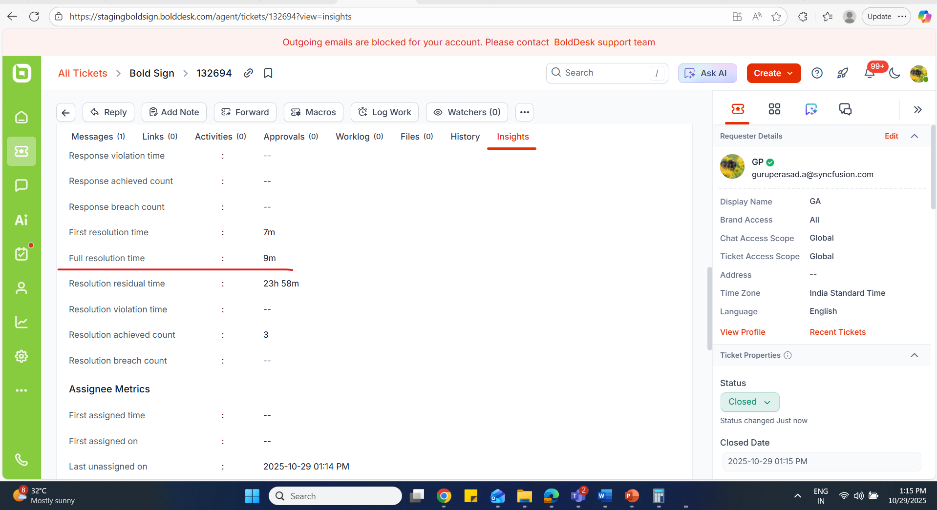 | PASSED
Ensure create ticket trigger case For status change.  And ensure “Full resolution time” updated in the insights tab correctly. | Automation trigger case:  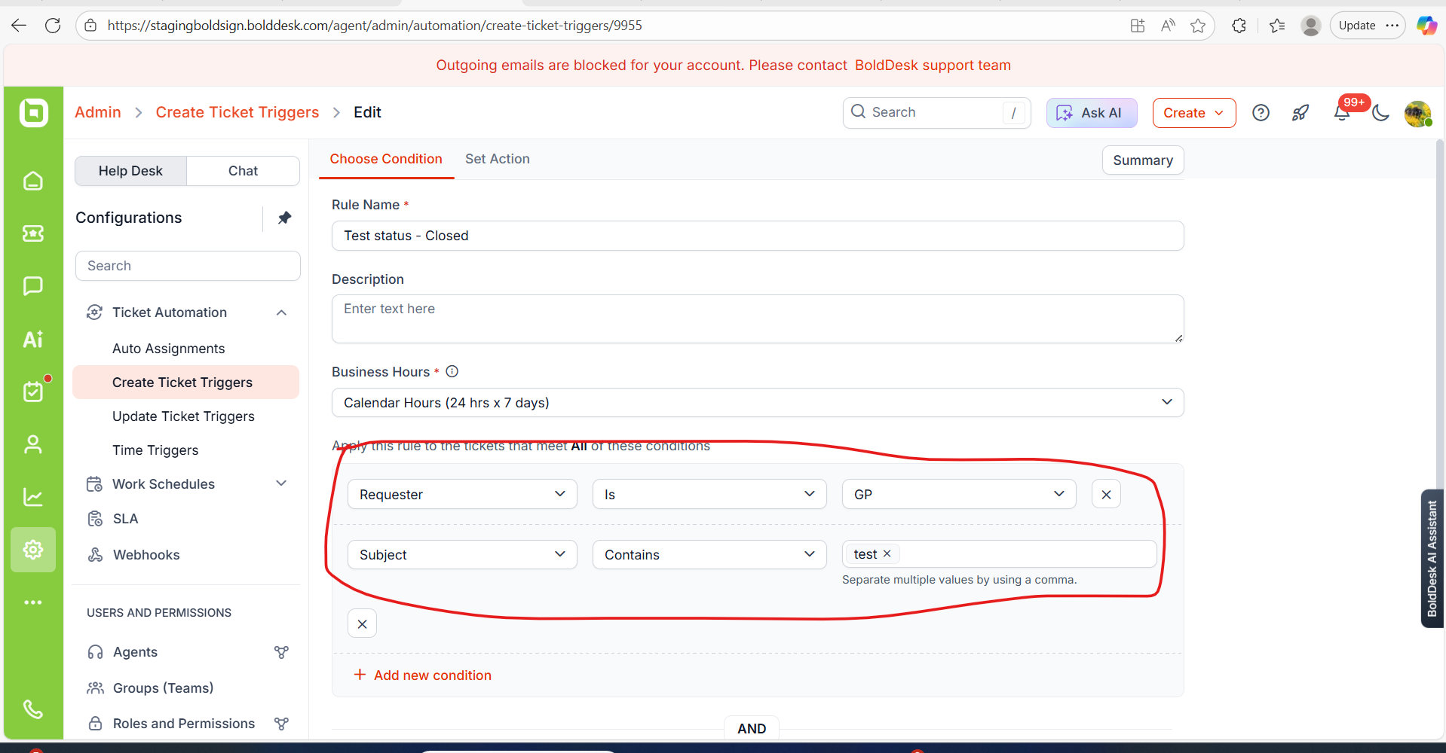  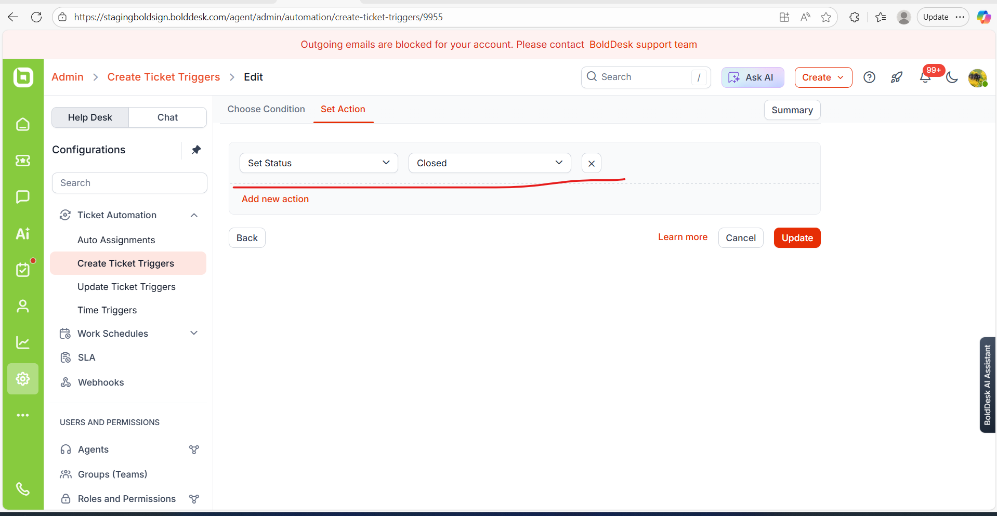  Automation rule applied:  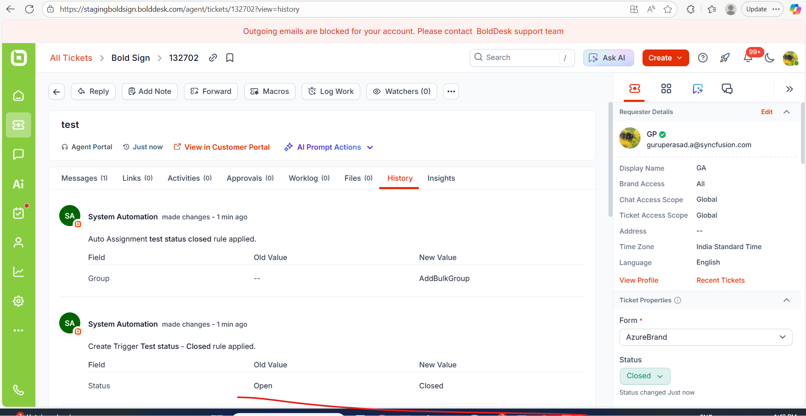  Time properly updated in the metrics field:  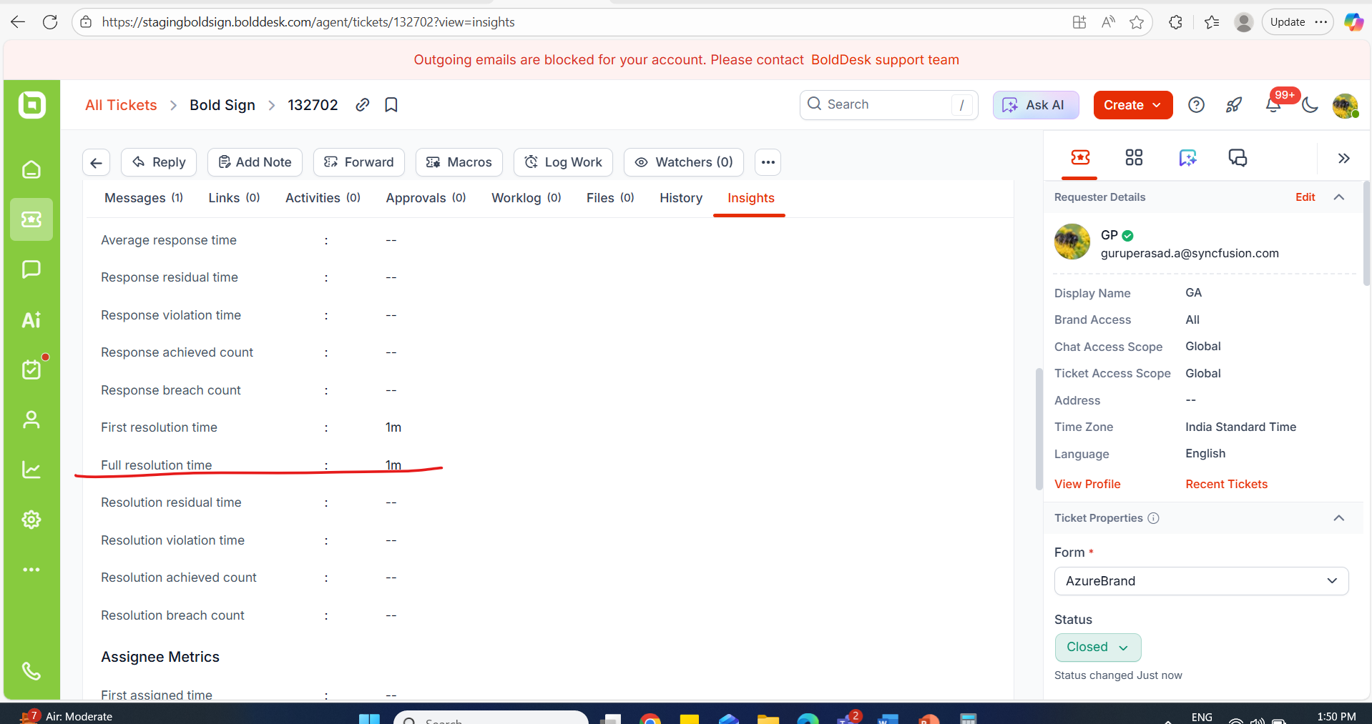 | PASSED
Ensure update trigger cases. | 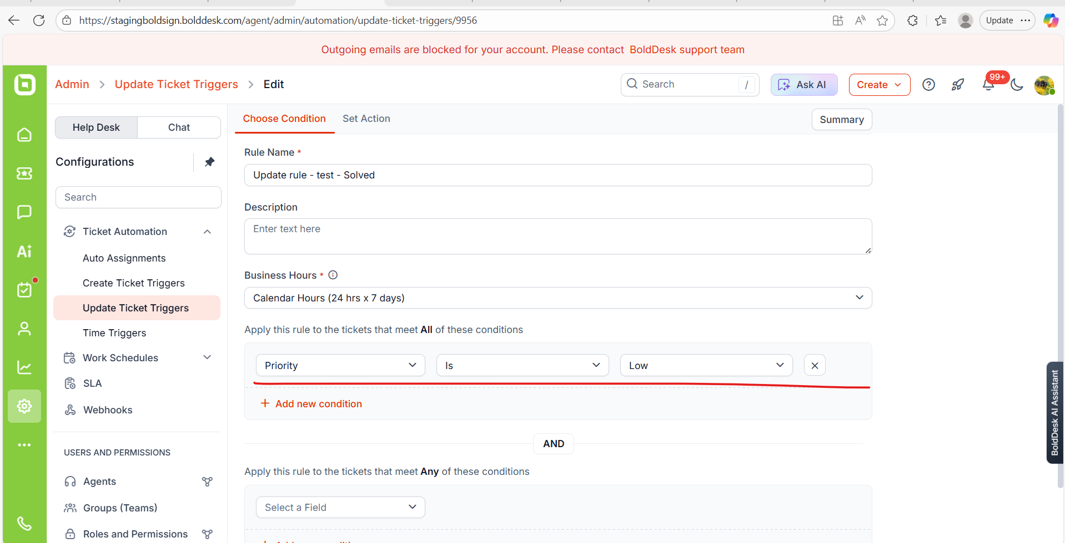  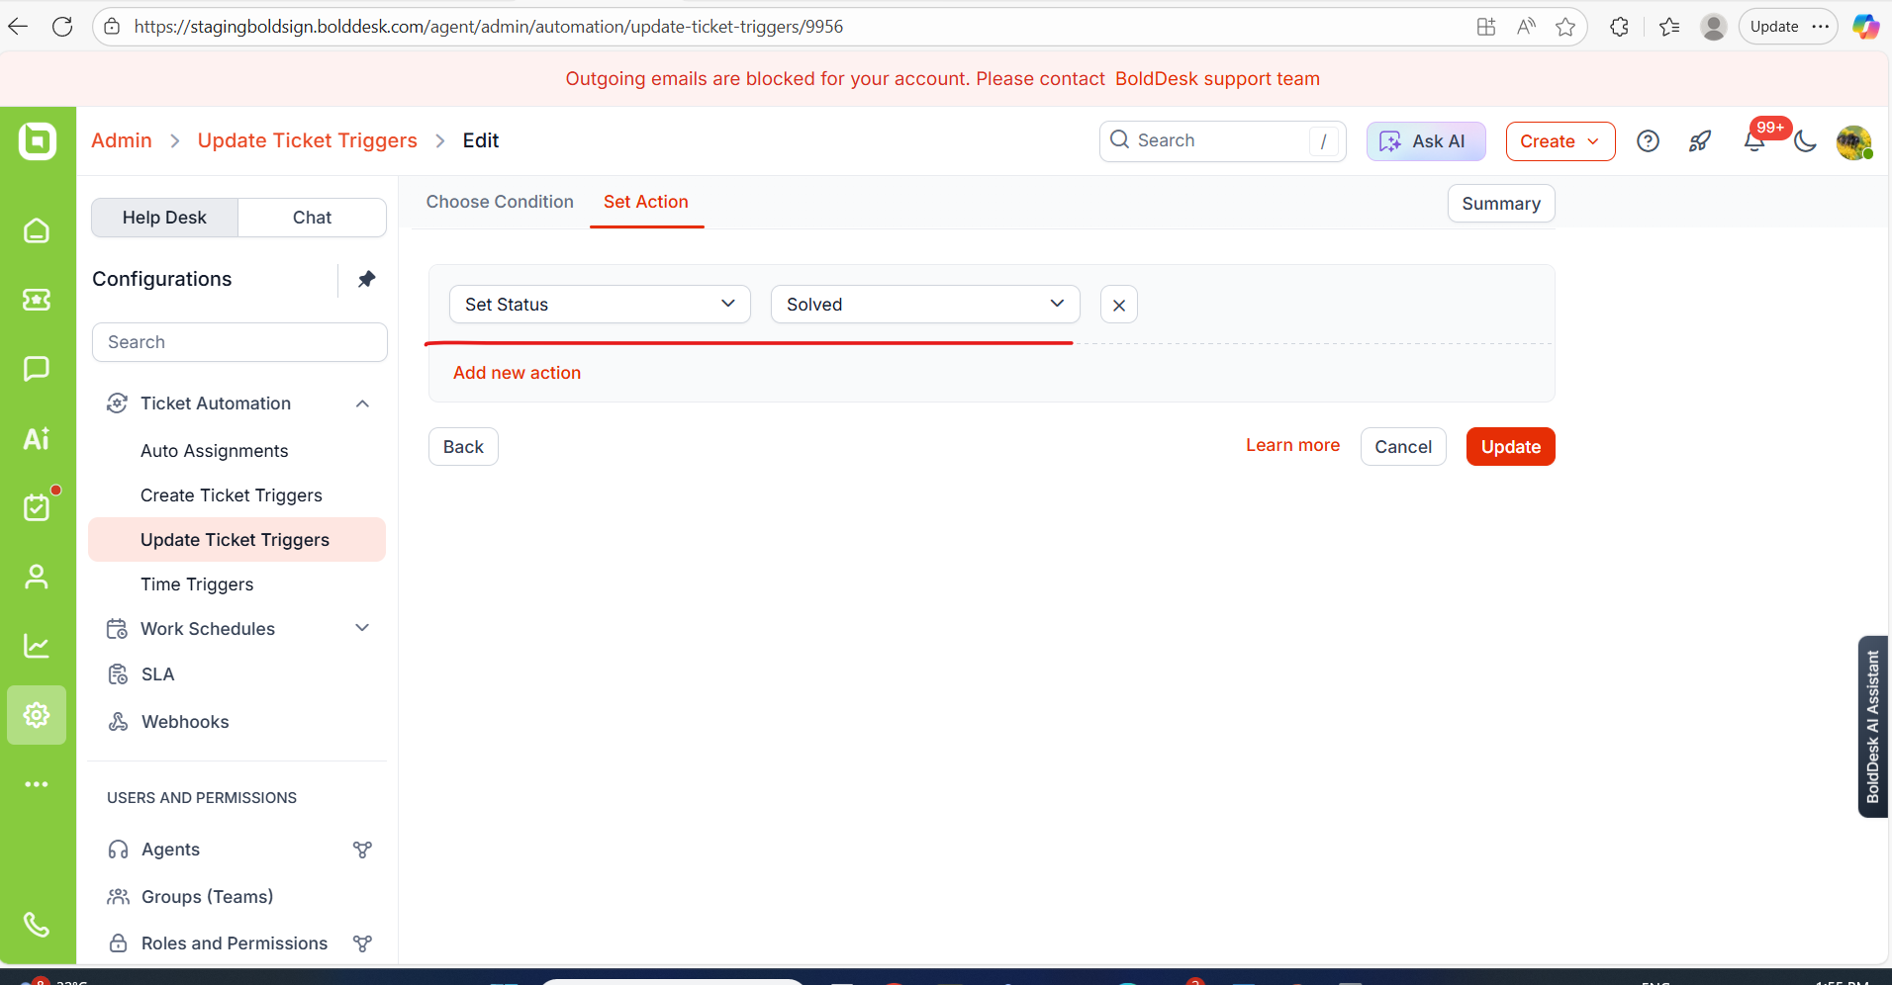  Event triggered:  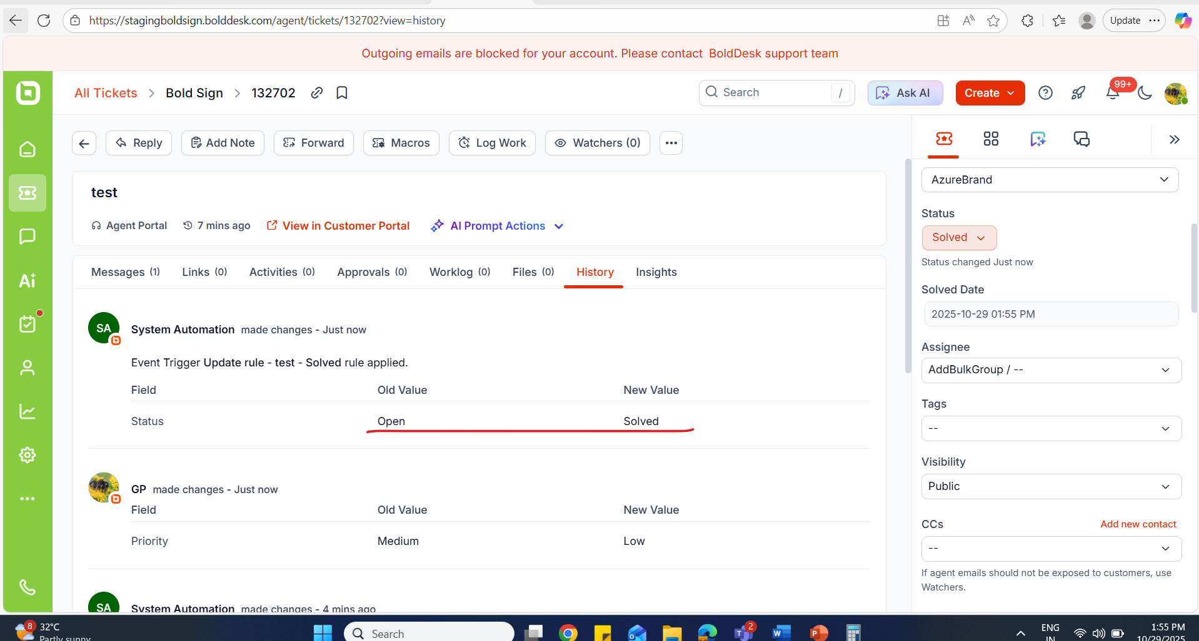  Full resolution time  Resolution residual time  Resolution achieved count value are binded correctly.  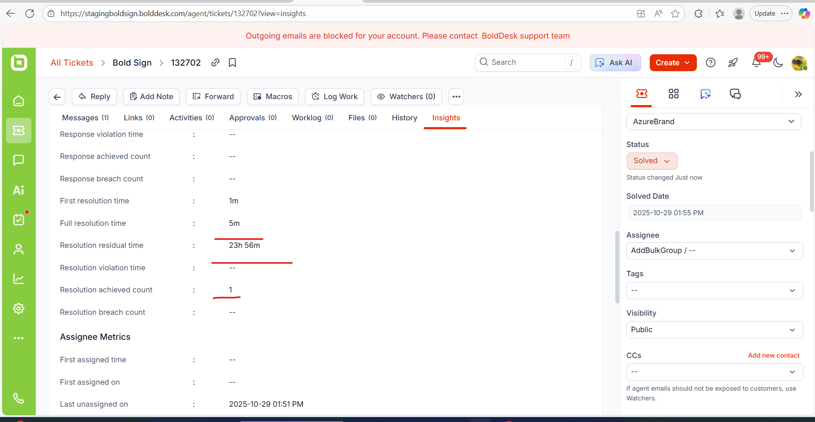 | PASSED
Ensured “Time trigger” cases. | 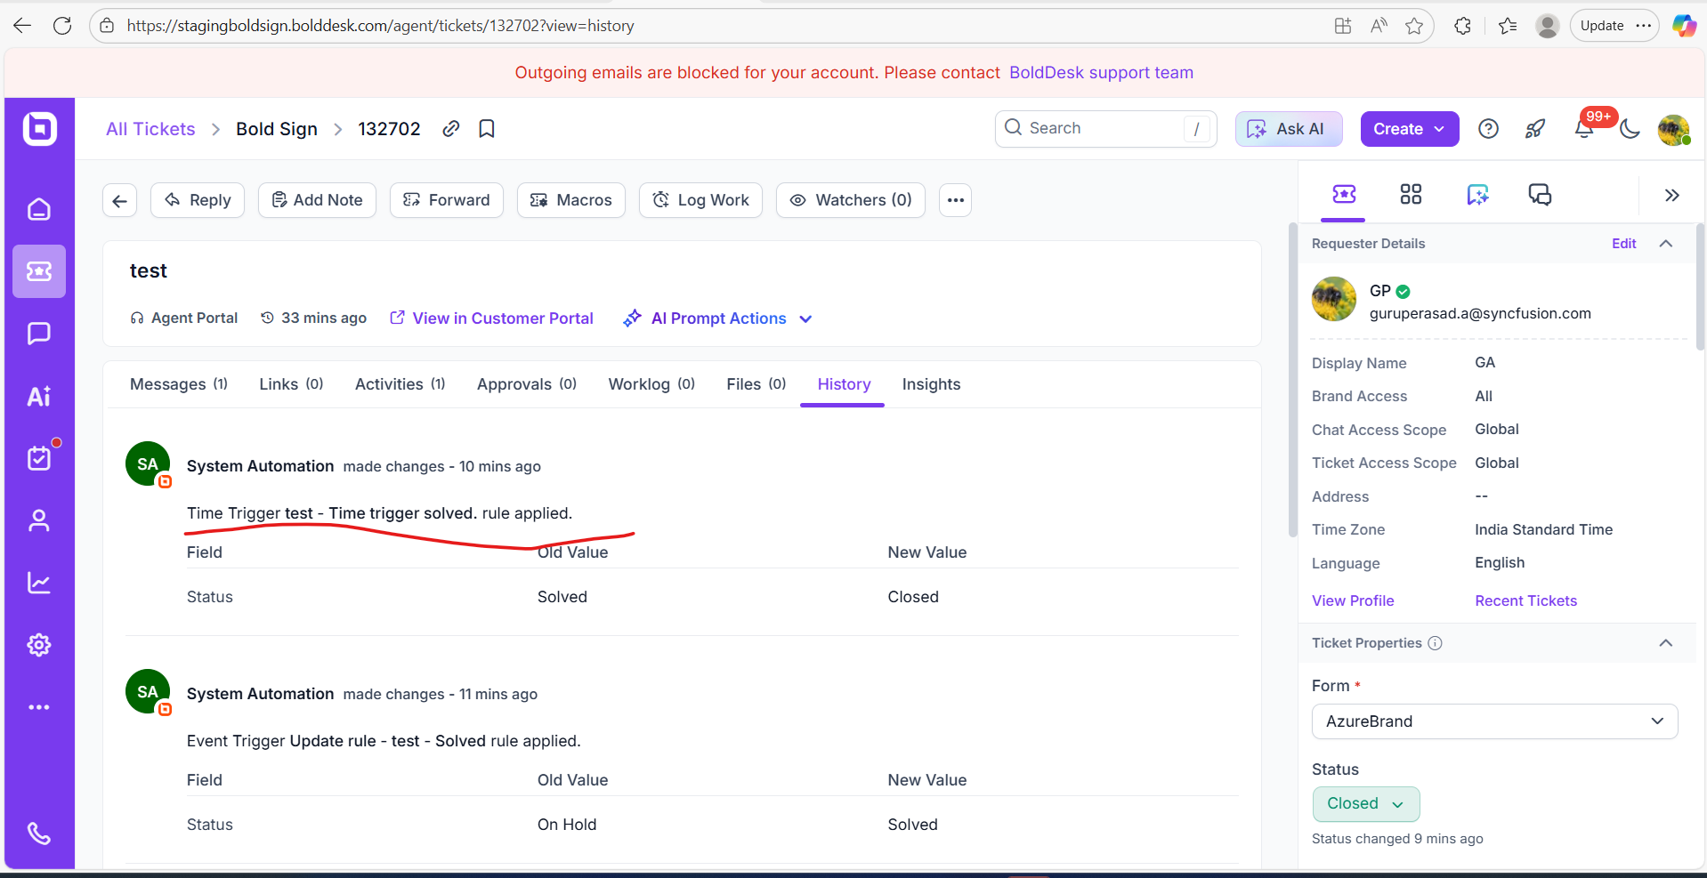  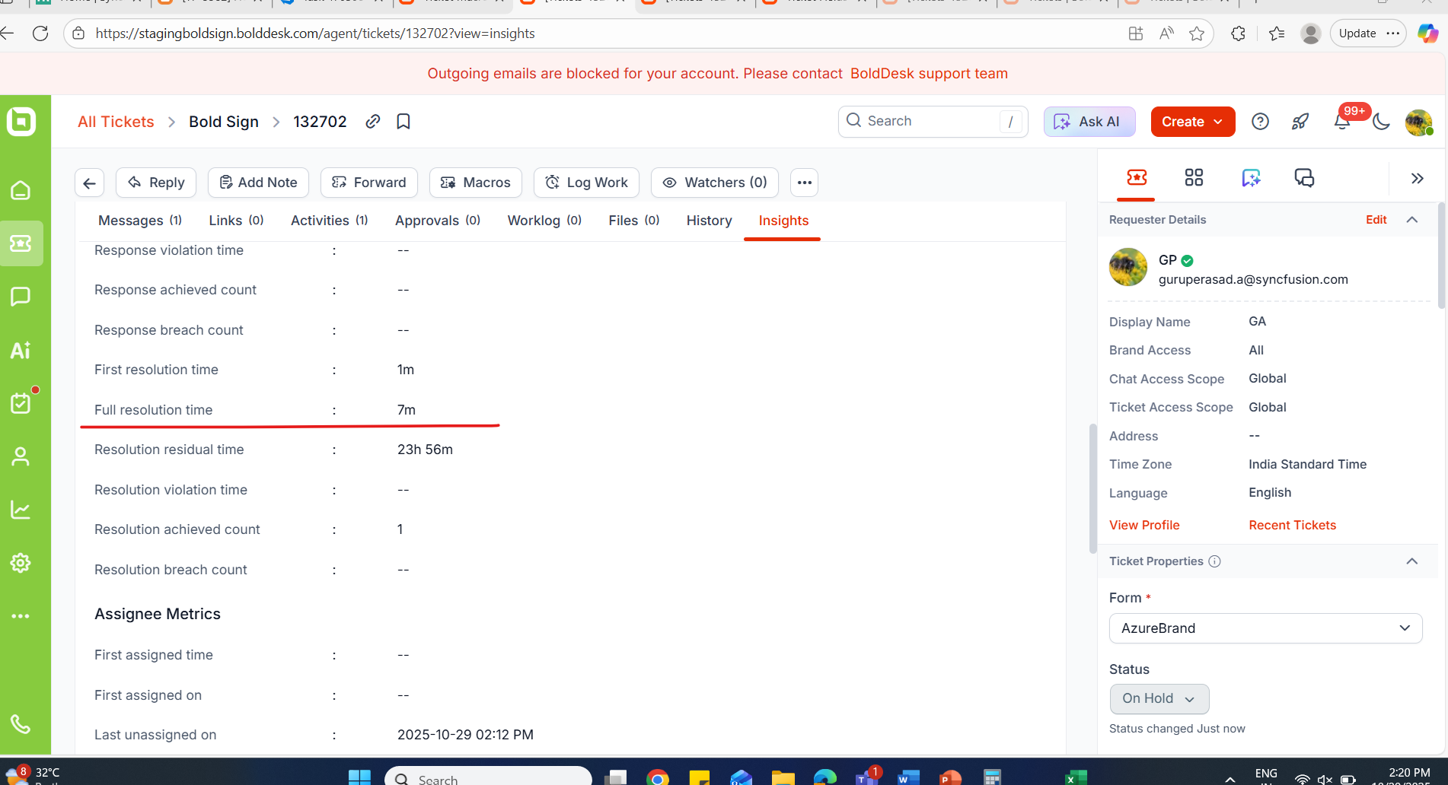 | PASSED
Before and After Macos rule triggered, ensured time in “Full resolution time” field. | Before applying “Macros rule” condition:  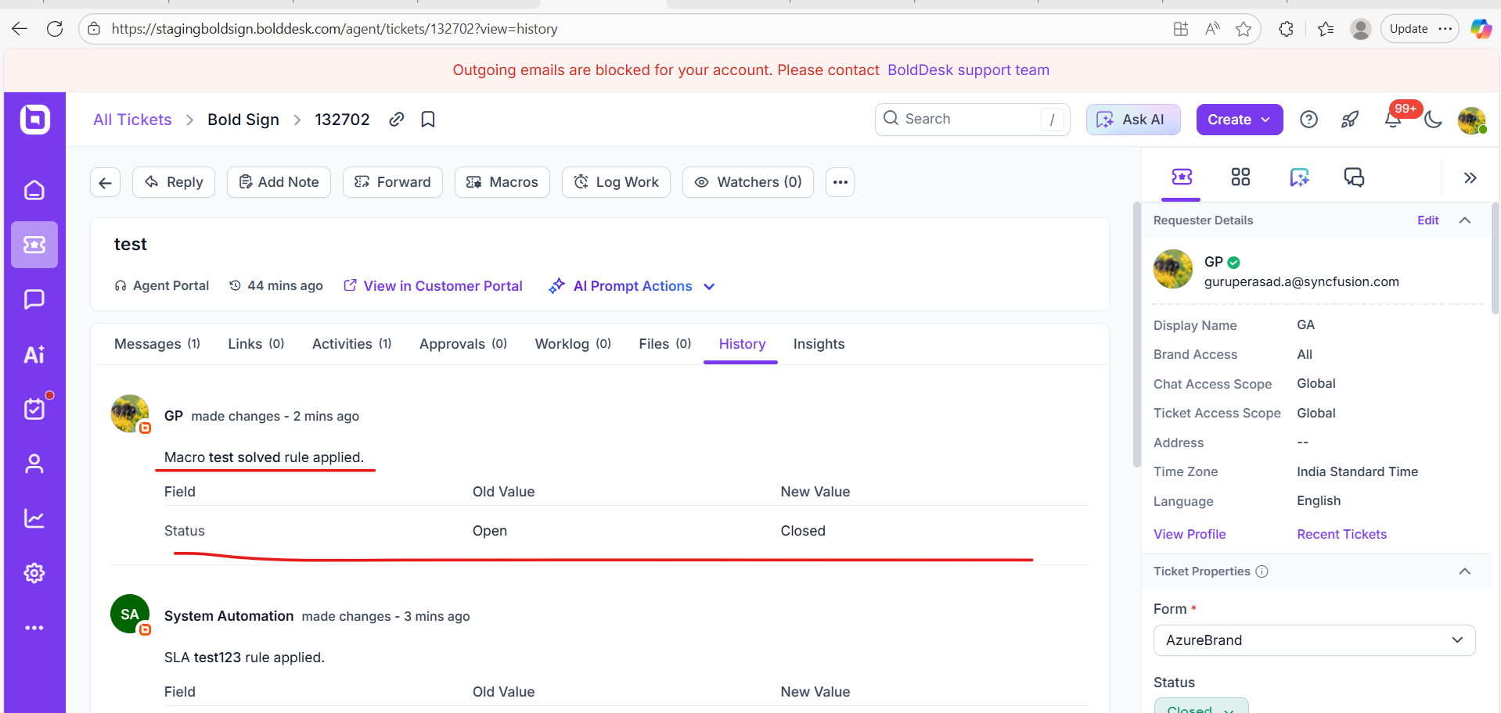  Before Applying “Macros rule” condition:  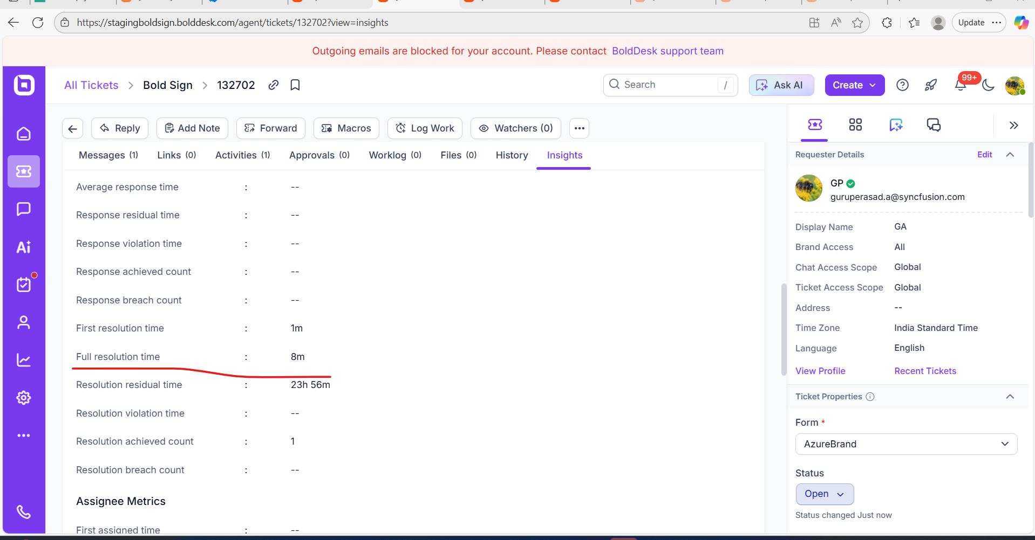  On Applying “Macros rule” :  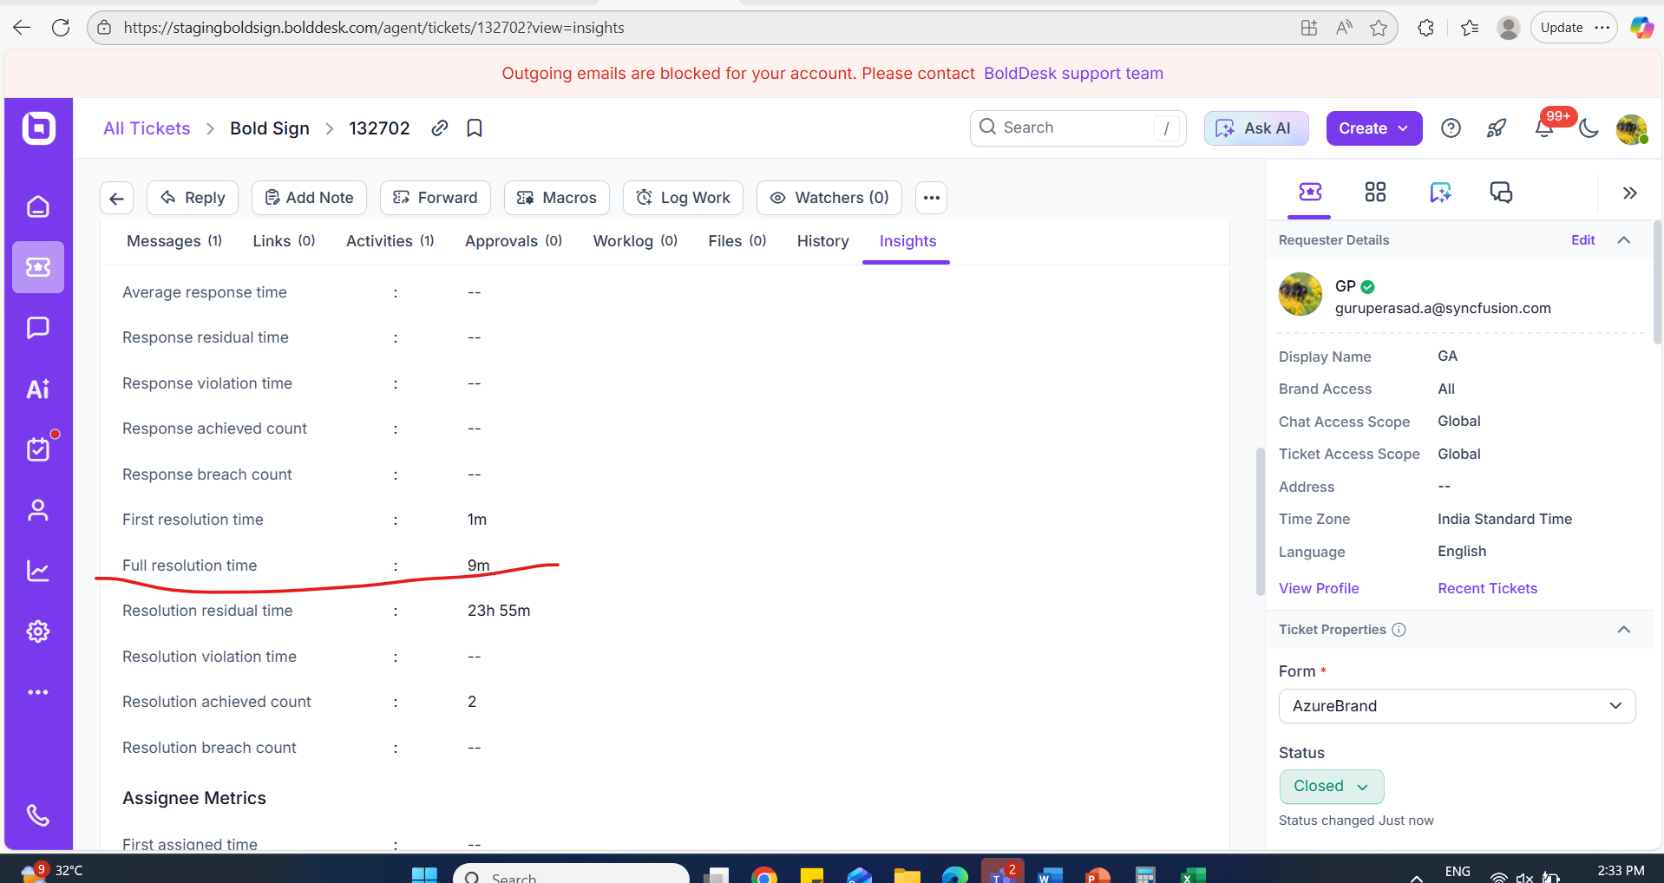 | PASSED
Ensure the case by changing the timezone and verify correct time is updated in the field. | 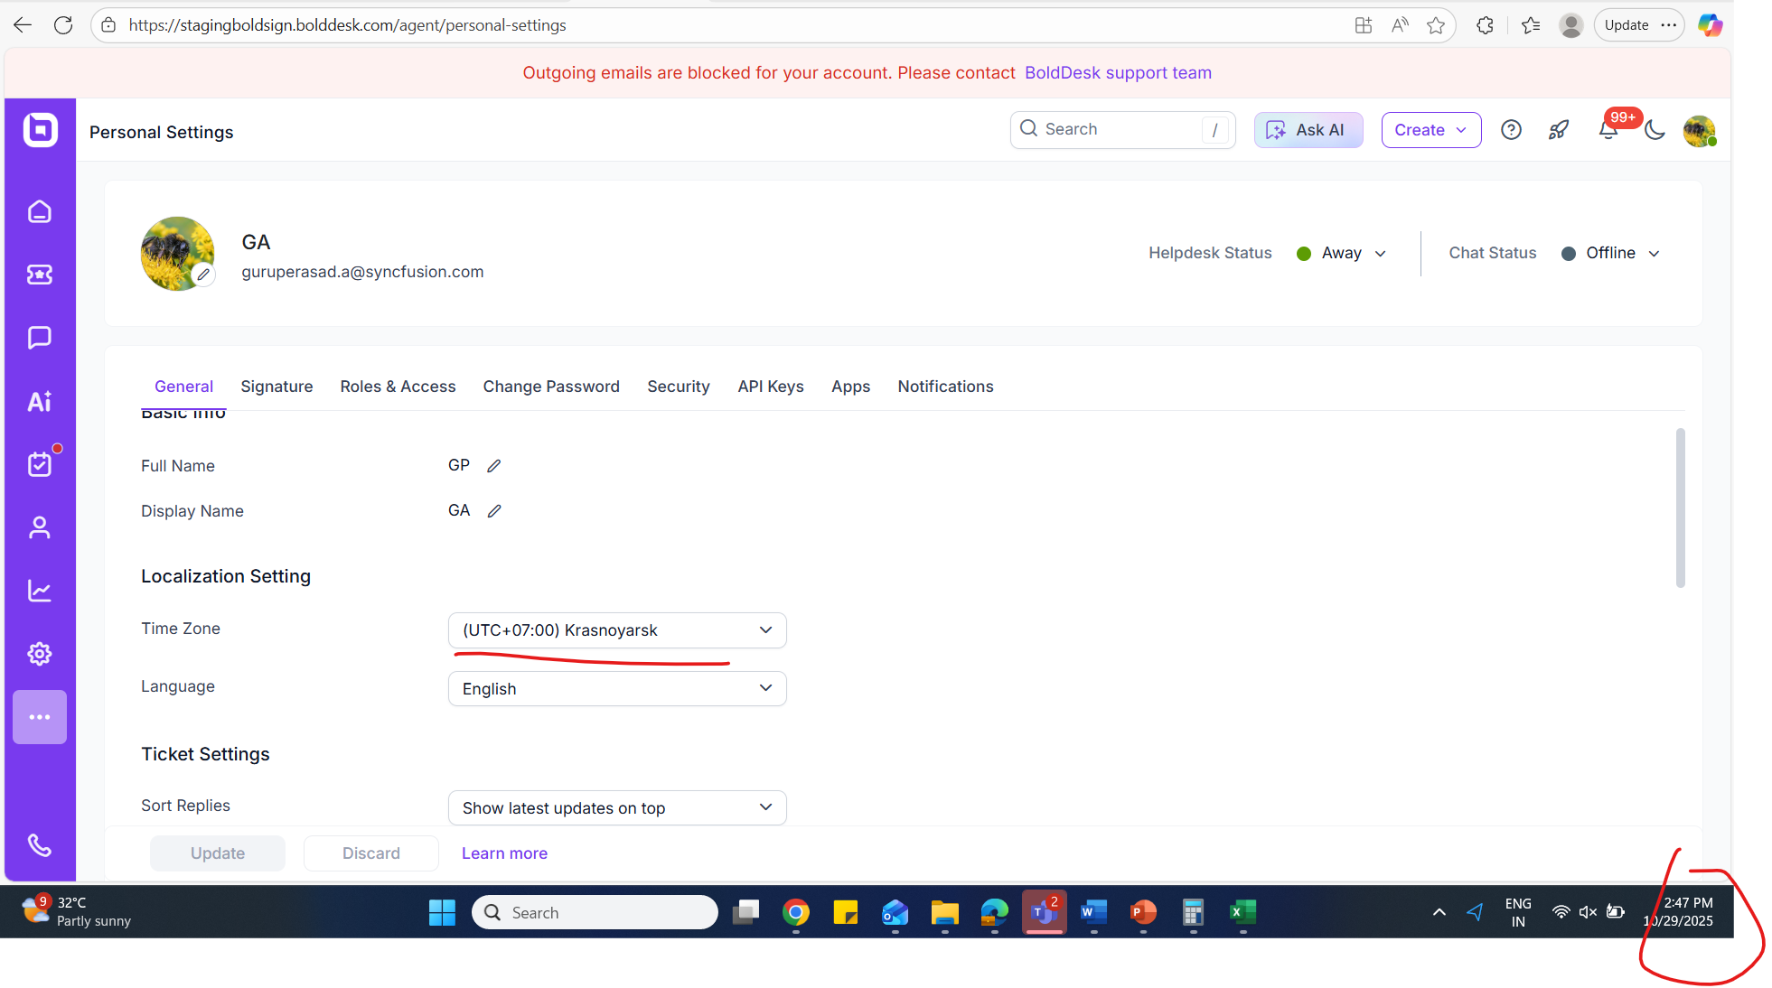  Time before :  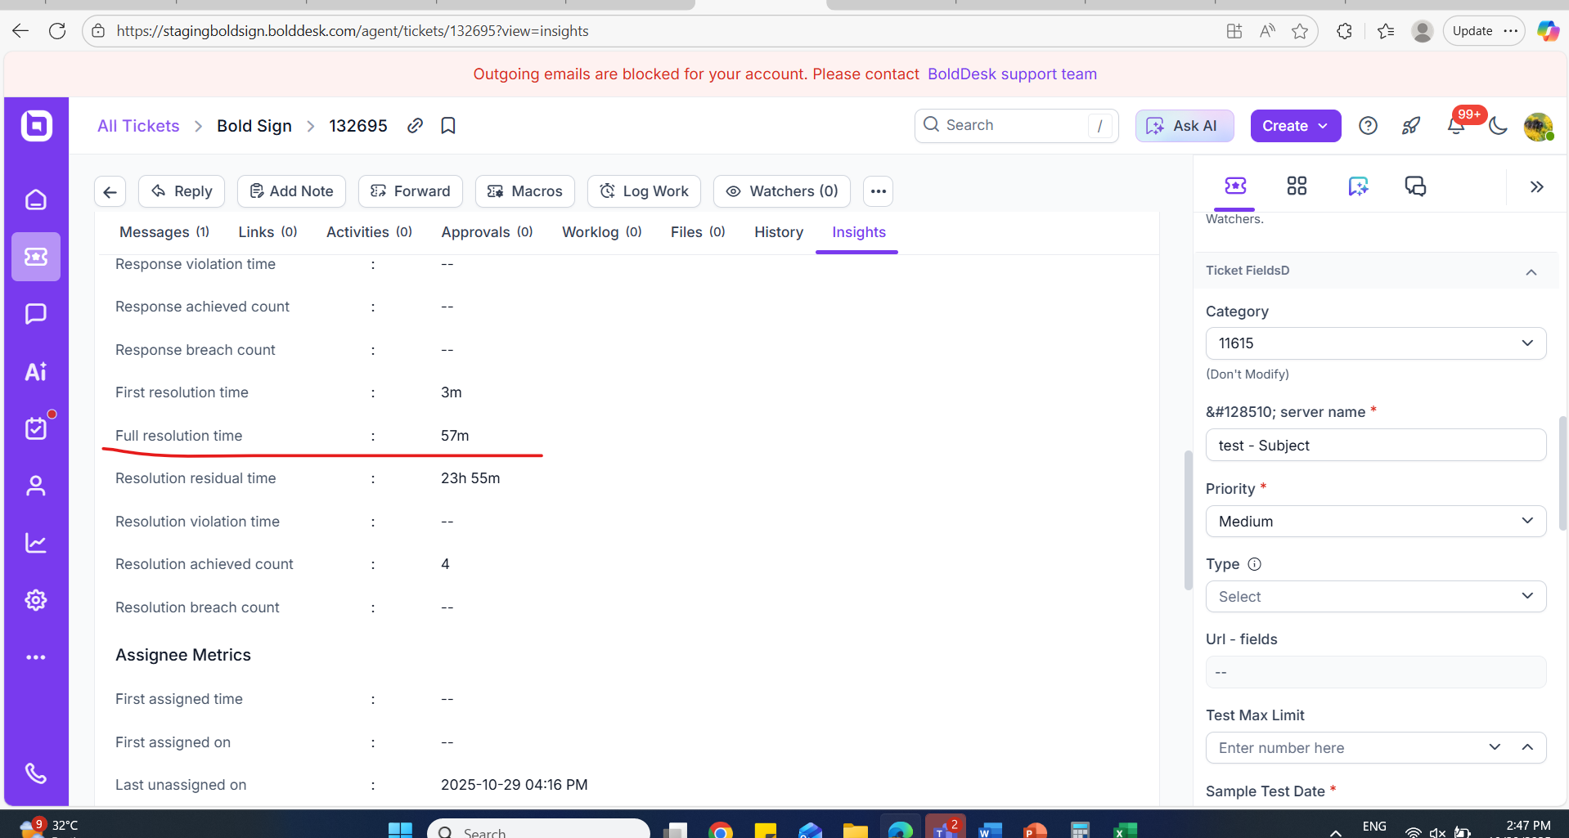  After update – Time updated correctly:  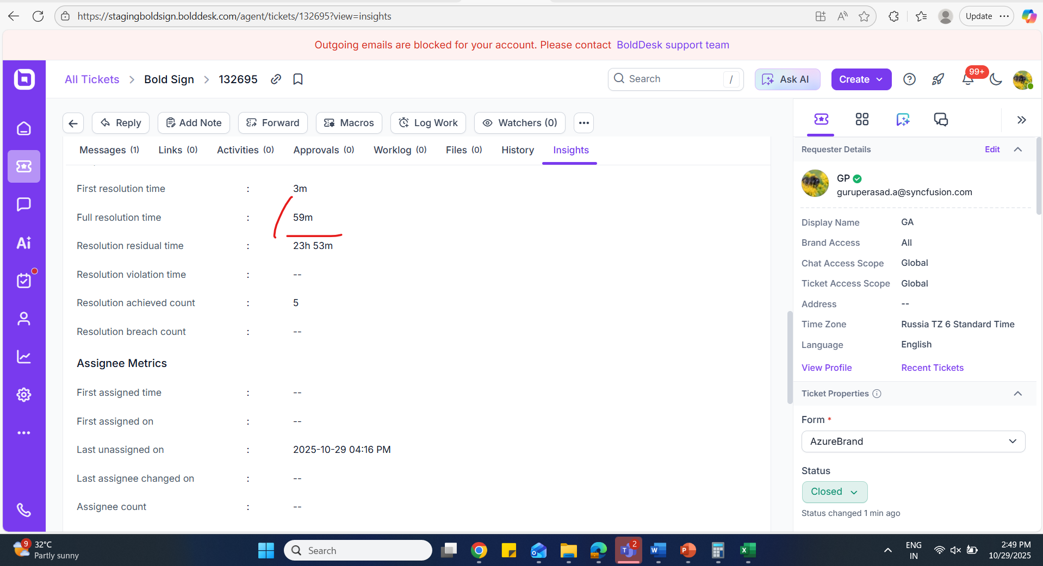 | PASSED

